HANOI UNIVERSITY OF SCIENCE AND TECHNOLOGY  
SCHOOL OF ELECTRICAL & ELECTRIC ENGINEERING



**PROJECT  
GRADUATION THESIS**  
**AUTOMATIC - CONTROL**

**TOPIC**  
 **INTERNET COMMUNICATION, MANAGEMENT AND CONTROL SYSTEM DESIGN**

|  |  |  |
| --- | --- | --- |
| **Supervisor** | **:** | ThS. ĐẶNG VĂN MỸ |
| **Students** | **:** | TRẦN VĂN NGUYÊN  NGUYỄN ĐỨC MINH |

HÀ NỘI, 8/2022

BỘ GIÁO DỤC VÀ ĐÀO TẠO  
 HANOI UNIVERSITY OF SCIENCE AND TECHNOLOGY

# **GRADUATION PROJECT DESIGN TASKS**

1. **Student Information:**

Name: Trần Văn Nguyên - 20181911

Nguyễn Đức Minh - 20181905

Class: CTTT - ĐK - TĐH – HTĐ – 001 - K63

1. **Tasks to perform:**

* Analysis, selection and design of smart home models.
* Designing communication, management and control systems for smart homes via the Internet
* Model scalability with peripheral devices and systems.

1. **Required content:**

* Design models with devices capable of automatic control, interacting with each other and with remote monitoring function, ensuring security and confidentiality.
* Designing communication, management and control systems for smart homes via the Internet
* Expand connectivity with peripherals

# **WORK DISTRIBUTION**

|  |  |  |
| --- | --- | --- |
| Timeline | Students made | Work description |
| 26/04 – 01/05 | Trần Văn Nguyên | Get topic: Internet communication, management and control system design |
| Nguyễn Đức Minh |
| 02/05 – 15/05 | Trần Văn Nguyên | Research, analyze and come up with some solutions to the topic |
| Nguyễn Đức Minh |
| 16/05 – 22/05 | Trần Văn Nguyên | * Implement the mechanical construction part * Buying components |
| Nguyễn Đức Minh |
| 23/05 – 29/05 | Trần Văn Nguyên | Complete the mechanical construction part |
| Nguyễn Đức Minh |
| 30/05 – 26/06 | Trần Văn Nguyên | * Hardware deployment * Node MCU ESP32 test function and research * Research about the sensors’s use in the system * Research about the platform to implement the application to control the system via internet |
| Nguyễn Đức Minh | * Hardware deployment * Arduino Nano test function and research * Research about the executive structure of the system (devices also) * Design schematic of the system |
| 27/06 – 03/07 | Trần Văn Nguyên | * Voltage supply analytic * Complete the hardware deployment part |
| Nguyễn Đức Minh |
| 04/07 – 17/07 | Trần Văn Nguyên | * Node MCU ESP32 programming part * Implement Blynk application |
| Nguyễn Đức Minh | * Arduino Nano programming part * Implement Blynk application |
| 18/07 - 24/07 | Trần Văn Nguyên | * Complete the design system and testing function * Complete the application * Writing report |
| Nguyễn Đức Minh |
| 25/07 – 07/08 | Trần Văn Nguyên | * Complete report * Writing powerpoint |
| Nguyễn Đức Minh |
| 08/08 – 14/07 | Trần Văn Nguyên | * Complete powerpoint |
| Nguyễn Đức Minh |

BỘ GIÁO DỤC VÀ ĐÀO TẠO  
 HANOI UNIVERSITY OF SCIENCE AND TECHNOLOGY

TEACHER'S COMMENTS

……………………………………………………………………………………  
………………………………………………………………………………………………………………………………………………………………………………………………………………………………………………………………………………………………………………………………………………………………………………………………………………………………………………………………………………………………………………………………………………………………………………………………………………………………………………………………………………………………………………………………………………………………………………………………………………………………………………………………………………………………………………………………………………………………………………………………………………………………………………………………………………………………………………………………………………………………………………………………………………………………………………………………………………………………………………………………………………………………………………………………………………………………………………………………………………………………………………………………………………………………………………………………

* INSTRUCTIONS POINTS:…………………………………………………………..

…………………………………………………………………………………………..

Date......month........year 2022

Supervisor (Sign)

# **PREFACE**

The 21st century society witnessed the tremendous development of technology and marked the beginning of smart devices. Smart phones, Smart TVs are increasingly popular devices, common in people's daily lives. As the name suggests, these devices are not only capable of meeting basic human requirements, but moreover, smart devices have been born that have replaced humans in controlling and controlling functions. other functions professionally, easily and effectively.

Following the success of those smart devices, Smart home was born as a bold start to thinking about mastering technology right in people's lives. A smart home with the ability to understand human control thinking quickly becomes a fascinating technology topic.

A smart home or smart home, home automation is a type of house in which electrical and electronic equipment is installed with the effect of fully or semi-automatically, replacing humans in performing one or several management operations. , control. This electronic system communicates with the homeowner through electronic devices placed in the home, mobile phone software, tablet computers or a web interface.

At first, the idea was realized using infrared for remote control, but the distance was limited. Later, many studies aimed at improving the control distance brought many successes and practical implications such as control via telephone lines, but this is still not the optimal solution. When wireless technology developed, people thought of wireless control, remote control using a computer was born. This project presents a solution to control and monitor the house intelligently through the Internet. This solution is very possible with a precise and stable operating mechanism to create a step to develop an intelligent system applied in practice. Data and device parameters of the smart home are transmitted to the website and interface software to help ensure a secure, safe and automatic mechanism.

The topic is a highly practical product based on current technological needs, researched and manufactured based on the knowledge we have learned, inherited and promoted the results of the research works. before.

I would like to thank my family and friends for creating conditions and helping me to complete this graduation project, especially the Smart Home team.

I would like to sincerely thank the teachers in the AUTOMATIC CONTROL department for their enthusiastic guidance so that my group could complete this research topic. In addition, the guidance and suggestions of the instructor MSc DANG VAN MY

Due to the limited time and knowledge, my topic will inevitably make mistakes, I hope the teachers can comment and edit it to be more complete.

Hà Nội, date......month......year 2022

Students made

# **ABSTRACT**

The main content of diploma project is to present IoT related issues. It’s SmartHome model, IoT’s application in building a real Smart Home.

The issues are presented in six chapters:

Chapter 1: Smart Home overview

Chapter 2: Overview design of smart home control system

Chapter 3: Microprocessor block

Chapter 4: Design system actuators structure for smart home

Chapter 5: Electronic components, design monitoring and alarm systems for smart home

Chapter 6: Smart home control and monitoring system

Chapter 7: Design and production of experimental models

Chapter 8: Conclusion

**TABLE OF CONTENTS**

GRADUATION PROJECT DESIGN TASKS 2

WORK DISTRIBUTION 3

PREFACE 7

ABSTRACT 9

CHAPTER 1: SMART HOME OVERVIEW 19

1. Smart home overview 19

1.1. Context and demand for smart home use 19

1.2. Smart home models are being applied today 22

**1.2.1.** **Smart home solutions in the world** 22

**1.2.2.** **Smart home solutions in Vietnam** 23

2. Select design direction 25

CHAPTER 2: OVERVIEW DESIGN OF SMART HOME CONTROL SYSTEM 27

1. Structural diagram of the house and function 27

1.1 Structural Diagram 27

1.2 Function 27

2. Working principal diagram 28

2.1 Electronic system 28

2.2 System circuit diagram 29

CHAPTER 3: MICROPROCESSORS – CONTROL BLOCK 30

1. Specification 30

2. Introduction of Arduino Nano 30

2.1 Overview 30

2.2 General structure 33

2.3 Source block 33

2.4 Memory 34

2.5 Specifications 34

3. Node MCU ESP32 36

2.1 What is ESP32 36

2.2 Specifications of ESP32 37

2.3 Different Ways to Program 37

2.4 ESP32 DevKit – The ESP32 Development Board 38

2.5 Layout 39

2.6 Pinout of ESP32 Board 41

2.7 Conclusion 41

CHAPTER 4: DESIGN SYSTEM ACTUATORS SYSTEM STRUCTURE FOR SMART HOME 41

1. Specification 41

2. Overview of the devices used in the actuator system 42

2.1 Servo motor SG90 42

2.2 5.6V/2.1A DC stepper motor and A4988 control module 43

2.3 MG996 RC Servo Motor 46

2.4 Stepper motor Size 42 17HS8401 47

3. Device modules used in model and function 48

3.1. Garden and periphery 48

3.2. Living room 50

3.3. Parking garage 53

3.4. Sleeping room 53

3.5. Entertainment/movie room 55

3.6. Kitchen 57

CHAPTER 5: ELECTRONIC COMPONENTS, DESIGN MONITORING AND ALARM SYSTEM FOR SMART HOME 59

1. Specification 59

2. Electric components and overview of sensors used in monitoring and warning systems 59

2.1 Temperature and humidity sensor DHT11 59

2.2 Gas sensor MQ2 61

2.3 Motion sensor HC-SR510 64

2.4 IR Infrared Obstacle Avoidance Sensor Module 66

2.5 Light Sensor 67

2.6 Rain sensor 70

2.7 Peltier Cooling Module 72

2.8 Module Relay 12V DC 74

2.9 Radiator fan 77

2.10 LCD 16x2 78

2.11 I2C Communication 80

2.12 Keypad 3x4 84

2.13 Button 85

2.14 Voltage Supply 86

2.15 IC 74HC595 88

2.16 Other components 91

3. Working principle of monitoring systems 92

3.1. Algorithm flowchart 92

3.2. Fire alarm system works based on temperature sensor DHT11 92

3.3. Gas leak alarm system 92

3.4. Intrusion warning system 93

CHAPTER 6: SMART HOME CONTROL AND MONITORING SYSTEM 93

1. Learn about Wi-Fi and how it works. 93

1.1. What is Wi-Fi? 93

1.2. Working principles of Wi-Fi 93

1.3. Some common potting standards. 94

1.4. How does Wi-Fi work? 94

2. IP Address 97

3. Blynk Application 97

4. Software 98

5. Design of monitoring and control system via internet 120

6. Principle of data transmission control: 121

7. Principle analysis in controlling a specific mechanism: 121

CHAPTER 7: DESIGN AND PRODUCTION OF EXPERIMENTAL MODELS 122

1. Results achieved 122

2. Monitoring and control interface 125

3. Comment 127

CHAPTER 8: CONCLUSION 127

1. Conclusion 127

2. Future work 128

References 128

**TABLE OF FIGURES**

Figure 1. 1 General model of smart home. 20

Figure 1. 2 World Smarthome market growth chart 21

Figure 1. 3 Smart home market growth chart only for North America market 21

Figure 1. 4 Smart home model of Compro Technology company. 22

Figure 1. 5 Smart home model of the company IEI Integration 23

Figure 1. 6 Smart home model Eco-Future-World 23

Figure 1. 7 Smart home model of BKAV 24

Figure 1. 8 Smart home model of Lumi 24

Figure 1. 9 Development trend of smarthome 26

Figure 2. 1 Structural diagram of smart house 27

Figure 2. 2 Functions to use 28

Figure 2. 3 The schematic diagram of the working principle of the electronic system 28

Figure 2. 4 System circuit diagram. 29

Figure 3. 1 Arduino nano 31

Figure 3. 2 Hardware Architecture of Arduino Nano 33

Figure 3. 3 ESP32 Architecture 36

Figure 3. 4 ESP32 DevKit Board 38

Figure 3. 5 ESP32 Chip Module Board 39

Figure 3. 6 ESP32 Layout 40

Figure 3. 7 ESP32 pinout 41

Figure 4. 1 Servo motor S90 42

Figure 4. 2 Servo motor S90 pinout 42

Figure 4. 3 A4988 module 44

Figure 4. 4 A4988 module pinout 44

Figure 4. 5 Circuit diagram of stepper DC and A4988 45

Figure 4. 6 MG996 RC Servo Motor Pinout 46

Figure 4. 7 Stepper motor 17HS8401 47

Figure 4. 8 Flowchart of garden and periphery system 49

Figure 4. 9 Flowchart of the password system 50

Figure 4. 10 Flowchart of the living room 52

Figure 4. 12 Flowchart of the bedroom 54

Figure 4. 13 Flowchart of the entertainment room 57

Figure 4. 14 Flowchart of the kitchen 58

Figure 5. 1 DHT11 sensor pinout 59

Figure 5. 2 MQ2 gas sensor module 61

Figure 5. 3 Structure of the MQ2 gas sensor module 62

Figure 5. 4 Motion sensor module HC-SR510 64

Figure 5. 5 HC-SR510 motion sensor input 64

Figure 5. 7 Diagram of IR Infrared Obstacle Avoidance Sensor Module 66

Figure 5. 8 Light sensor pinout 68

Figure 5. 9 Light sensor principle diagram 1 69

Figure 5. 10 Light sensor principle diagram 2 70

Figure 5. 11 Rain sensor 71

Figure 5. 12 Peltier cooling module 73

Figure 5. 13 Peltier cooling module configuration 74

Figure 5. 14 Module Relay 12V DC 2 channels 75

Figure 5. 15 Module Relay 12V DC 1 channel 76

Figure 5. 16 Module Relay 12V DC working principle 1 76

Figure 5. 17 Module Realy 12V DC working principle 2 77

Figure 5. 18 Radiator fan 78

Figure 5. 19 LCD 16x2 78

Figure 5. 20 LCD 16x2 pinout 79

Figure 5. 21 I2C structure 81

Figure 5. 22 I2C transmission frame 82

Figure 5. 23 I2C address bit block 82

Figure 5. 24 I2C address bit block 83

Figure 5. 25 I2C module 84

Figure 5. 26 Keyboard 3x4 85

Figure 5. 27 Button working principle 86

Figure 5. 28 Button 86

Figure 5. 29 Apdater 12V – 5A 87

Figure 5. 30 Apdater 12V – 5A 88

Figure 5. 31 Non-Isolation Voltage Supply 88

Figure 5. 32 74HC595 pinout diagram 89

Figure 5. 33 74HC595 shift register working principle 91

Figure 5. 34 Algorithm flowchart of monitoring systems 92

Figure 6. 1 Interface of the Arduino software 99

Figure 6. 2 Arduino Setup Preferences 99

Figure 6. 3 Arduino boards manager 100

Figure 6. 4 Arduino setup ESP32 librabry 100

Figure 6. 5 Create Blynk project 101

Figure 6. 6 Create Blynk project 102

Figure 6. 7 Blynk hardware configuration 2 103

Figure 6. 8 Blynk widget configuration 104

Figure 6. 9 Blynk switch configuration 105

Figure 6. 10 Blynk interface 1 106

Figure 6. 11 Blynk interface 2 109

Figure 6. 12 Blynk PC login 110

Figure 6. 13 Blynk PC template creation 111

Figure 6. 14 Blynk PC setup application 112

Figure 6. 15 Datastreams Blynk PC configuration Virtual pin 1 113

Figure 6. 16 Datastreams Blynk PC configuration Virtual pin 2 114

Figure 6. 17 Blynk PC dashboard 1 115

Figure 6. 18 Blynk PC dashboard 2 116

Figure 6. 19 Blynk PC new device 117

Figure 6. 20 Blynk PC new device result 1 118

Figure 6. 21 Blynk PC new device result 1 119

Figure 6. 22 Block diagram of the monitoring and control system 120

**TABLE OF TABLES**

Table 4. 1 MG996 RC Servo Motor pinout description 46

Table 4. 2 Stepper motor 17HS8401 specification 47

Table 5. 1 DHT11 pinout description 56

# **CHAPTER 1: SMART HOME OVERVIEW**

## **Smart home overview**

### **Context and demand for smart home use**

Today, as the standard of living is improving, people's needs require the best comforts and support. Along with that, the continuous expansion of the internet network across countries and territories makes monitoring and controlling the system via the internet a necessity. From those actual requirements and conditions, the idea of ​​a smart home was formed, where all human activities are supported and helped flexibly, in addition, the house can also be self-contained. management in the most intelligent way.

So, what is a smart home?

The intelligence of a house is shown in four aspects as follows:

* The first is automation. The house is equipped with a system of sensors such as temperature sensor, humidity sensor, gas sensor, fire alarm sensor, obstacle sensor, light sensor ... with the ability to automatically operate according to environmental conditions. Smart homes help us monitor electricity and water consumption better than usual.
* Second, is the ability to satisfy user needs. The owner of the house can control it at will or according to pre-programmed scenarios.
* Third, is the ability to security, monitor security. The security monitoring system, fire alarm, gas leak alarm system will automatically report the status of the house via the internet.
* Fourth, is the ability to control and warn remotely via internet connection via wifi, 3g... Devices such as light bulbs, air conditioners, televisions, refrigerators, ... are also connected to Internet. Users only need an internet-connected device to be able to monitor data from sensors and control devices in the home as they wish.

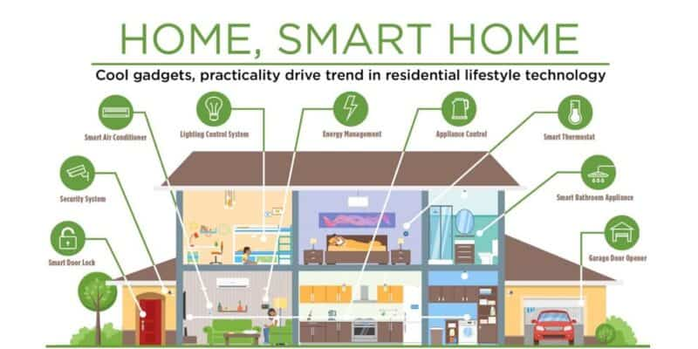

Figure 1. General model of smart home.

Currently, smart home has been a potential market with a global market of up to billions of dollars. Not only that, the North American market alone, according to the statistics, is completely reasonable to assume that this is the future of a house that we need to have.

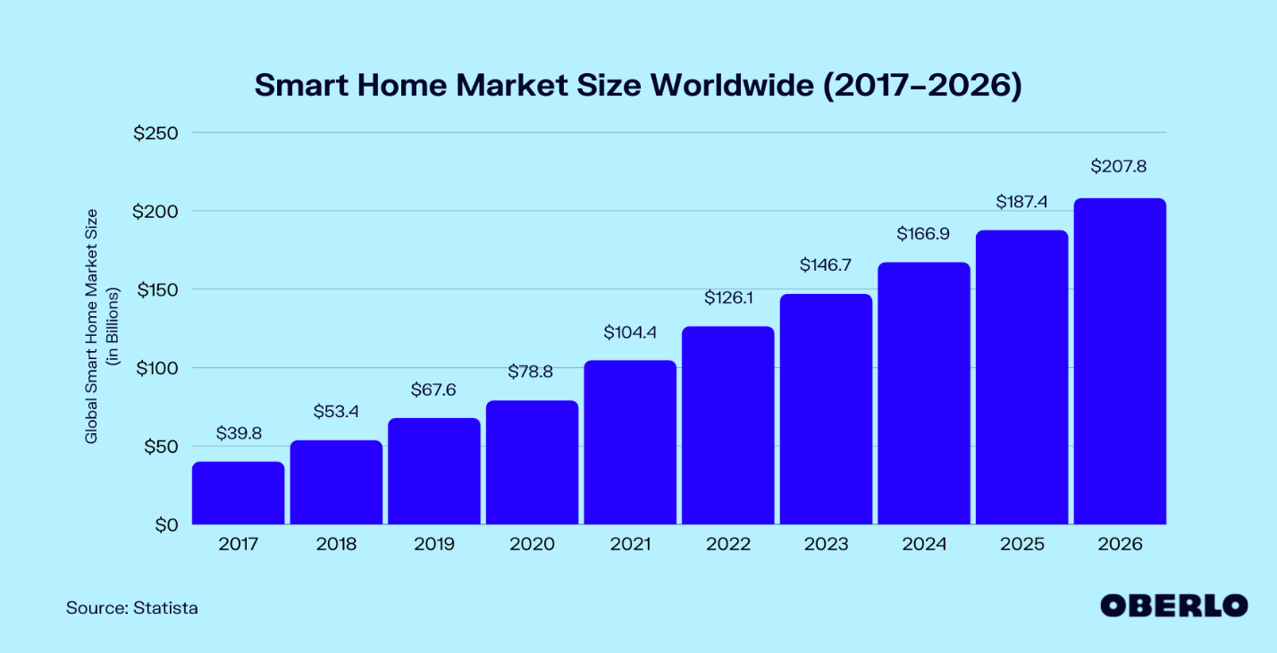

Figure 1. World Smarthome market growth chart

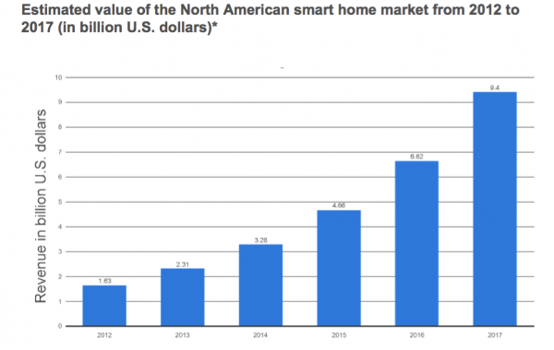

Figure 1. Smart home market growth chart only for North America market

### **Smart home models are being applied today**

#### **Smart home solutions in the world**

Currently the largest Smart home market in the world is North America. With the scale and comfort for a house with 4 people, there will be a basic design with capabilities such as: Intrusion warning, gas warning, automatic door system, security camera system, entertainment system…

Here is an example of a smart home from several manufacturers in the US and Europe, with standards from basic to high-end for a family:

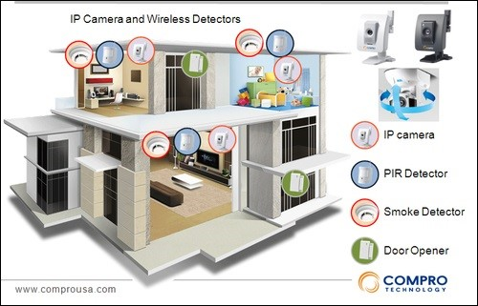

Figure 1. Smart home model of Compro Technology company.

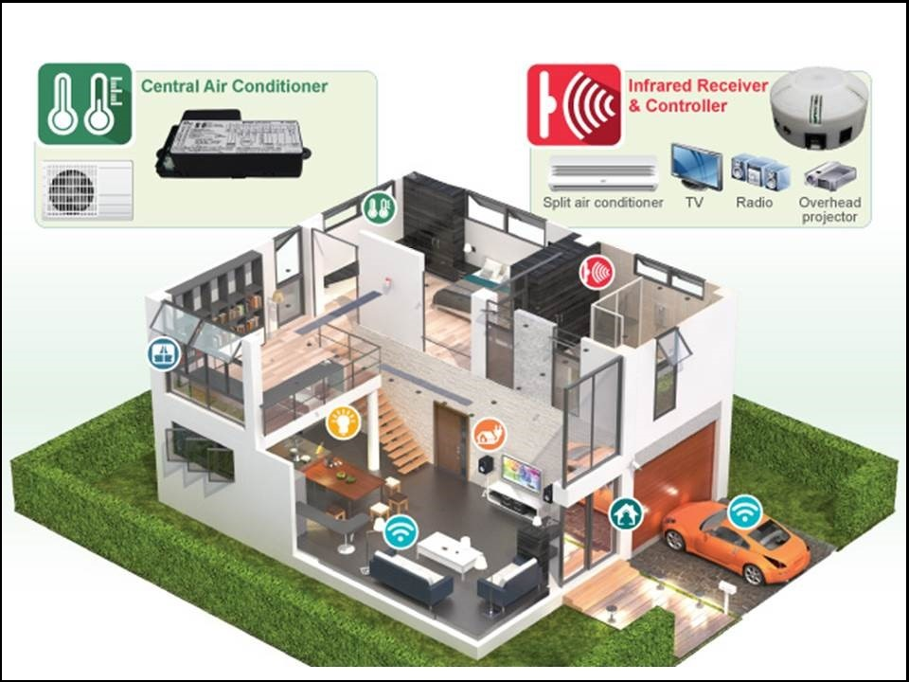

Figure 1. Smart home model of the company IEI Integration

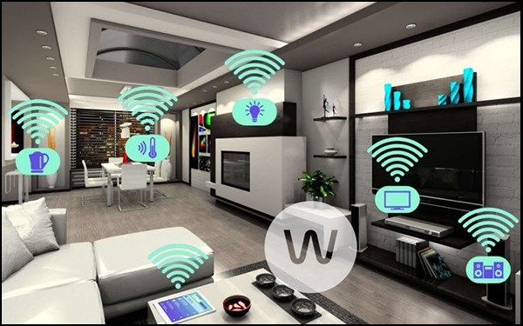

Figure 1. Smart home model Eco-Future-World

#### **Smart home solutions in Vietnam**

In Vietnam, not outside of the smart home technology flow, there have been many old and new manufacturers entering this potential market, led by BKAV and Lumi Smart home. With full functions like foreign manufacturers, plus factors suitable for the Vietnamese market, they currently have a significant advantage over foreign manufacturers in Vietnam.

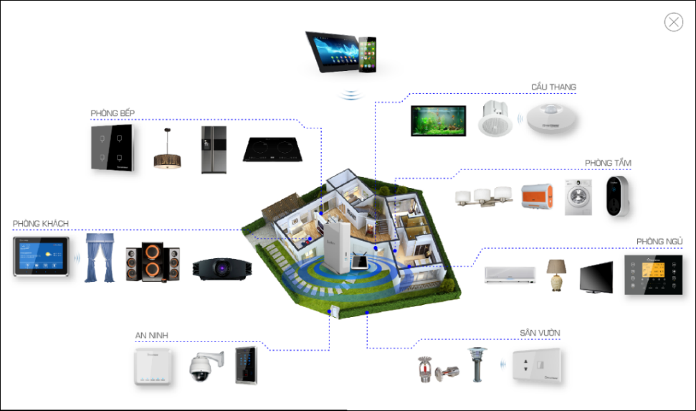

Figure 1. Smart home model of BKAV

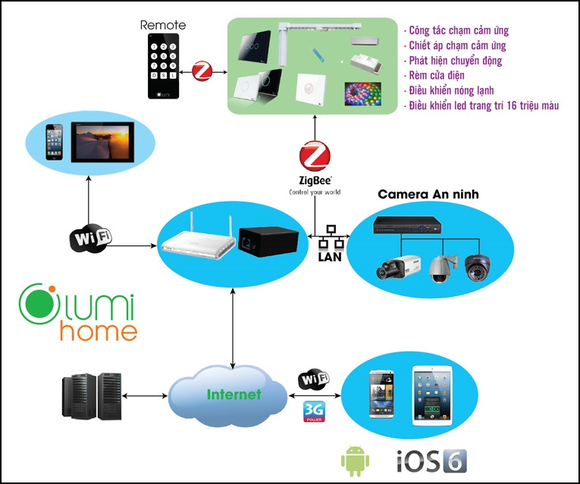

Figure 1. Smart home model of Lumi

## **Select design direction**

Smart home is a broad topic and has many problems. Depending on the intended use of the owner to design, an important part of the smart home system is the control and monitoring system.

In the past, smart homes were purely in the imagination as well as in the movies. Thanks to the continuous development of science and technology, smart home solutions are increasingly rich and convenient for users.

From the beginning, smart home only has remote control devices within the house to serve some human needs. Next is the automation of devices in the house with the ability to automatically adjust to the environment as well as the user.

Then, with the development and spread of the internet, people came up with a solution to connect and control home appliances through the internet and add conveniences such as safety systems, computing power, etc. energy usage, etc. helps the owner to control the device at a distance, not confined to the premises of the house anymore.

Security is also a top priority, because along with an internet connection, the possibility of being hacked into the system to gain control also increases. Owners can use their own passwords to log in to the system as well as the house through forms such as Passcode, fingerprint security, iris security... Accompanied by the ability to warn of intruders to help homeowners detectable anywhere with Wifi/GPRS connection.

And recently, the trend of controlling devices by voice has also been added to the smart home building solution, making it easier for everyone in the house to use. In the future, thanks to new technological devices combined with artificial intelligence, the house can distinguish each member's voice and remember the habits of each family member.

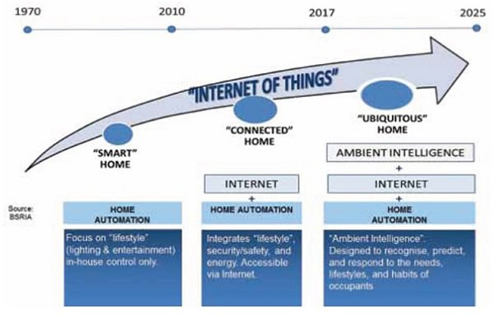

Figure 1. Development trend of smarthome

Currently, in Vietnam, the solution to build smart homes with control and monitoring systems via the internet is still the most popular and developed because it is suitable with existing technological capabilities and economic conditions.

My group feels that this topic is suitable for the major of AUTO CONTROL - AUTOMATIC as well as high-tech flow, so in this topic, my group would like to choose to design a smart house according to the solution using the system. system to control and monitor devices in the house via the internet, specifically the wifi network on a smart home model with a scale of 1000cm x 800cm with basic functions such as: automatic door opening/closing, fire monitoring and warning, gas leak warning, unauthorized intrusion warning, automatic curtains according to light, lights and fans turn on automatically according to the user and ambient temperature...

# **CHAPTER 2: OVERVIEW DESIGN OF SMART HOME CONTROL SYSTEM**

## **Structural diagram of the house and function**

### **Structural Diagram**

From an ordinary house, we choose to design a basic model for a family with 4 people, with designs including:

* Garden and periphery
* 1 living room
* 1 bedroom
* 1 kitchen area
* 1 garage
* 1 movie entertainment room

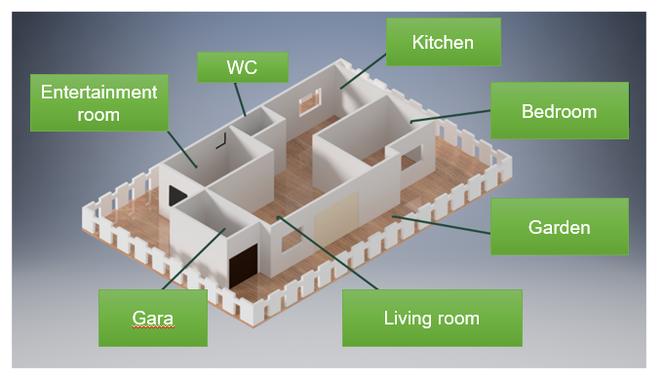

Figure 2. Structural diagram of smart house

### **Function**

With the criteria of smart home in Vietnam, we choose the functions to create a smart home with utilities such as:

* Open door with password
* Automatic curtain system according to ambient light
* Temperature and humidity notification system.
* The clothesline system automatically adjusts to the weather.
* Automatic movie mode at the movie theater.
* Automatic gas leak and fire alarm system.
* Automatic air conditioning system, lights, fans.
* Remote control system via phone app.

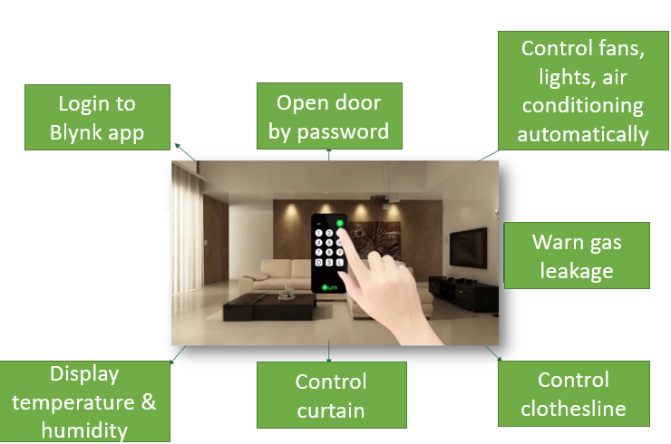

Figure 2. Functions to use

## **Working principal diagram**

### **Electronic system**

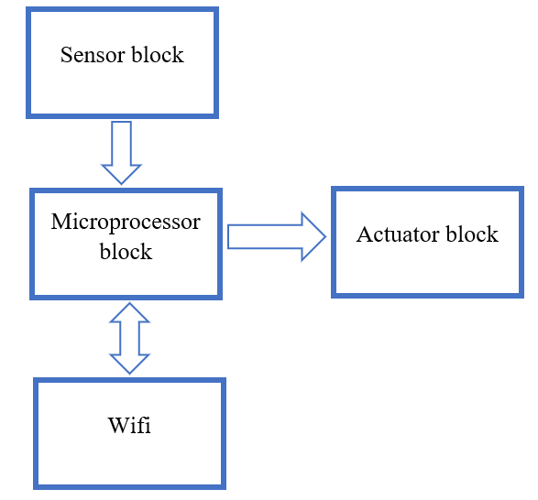

Figure 2. The schematic diagram of the working principle of the electronic system

1. *Sensor block:*

* Temperature sensor: the output signal is an analog signal.
* Humidity sensor: the output signal is a digital signal.
* Motion sensor: the output signal is a digital signal.
* Gas sensor: the output signal is a digital signal.
* Infrared sensor: the output signal is a digital signal.
* Light sensor: the output signal is a digital signal.
* Rain sensor: the output signal is a digital signal.

1. *Processing block:*

* Arduino Nano.
* MCU ESP32.

1. *Automatic control block via Blynk application.*

* Node MCU ESP32
* Wi-Fi
* Blynk App

1. *Executive block:*

* Garage door.
* Doors.
* Bedroom and movie room curtains.
* Clothesline.
* Fan, light.
* Siren.

### **System circuit diagram**

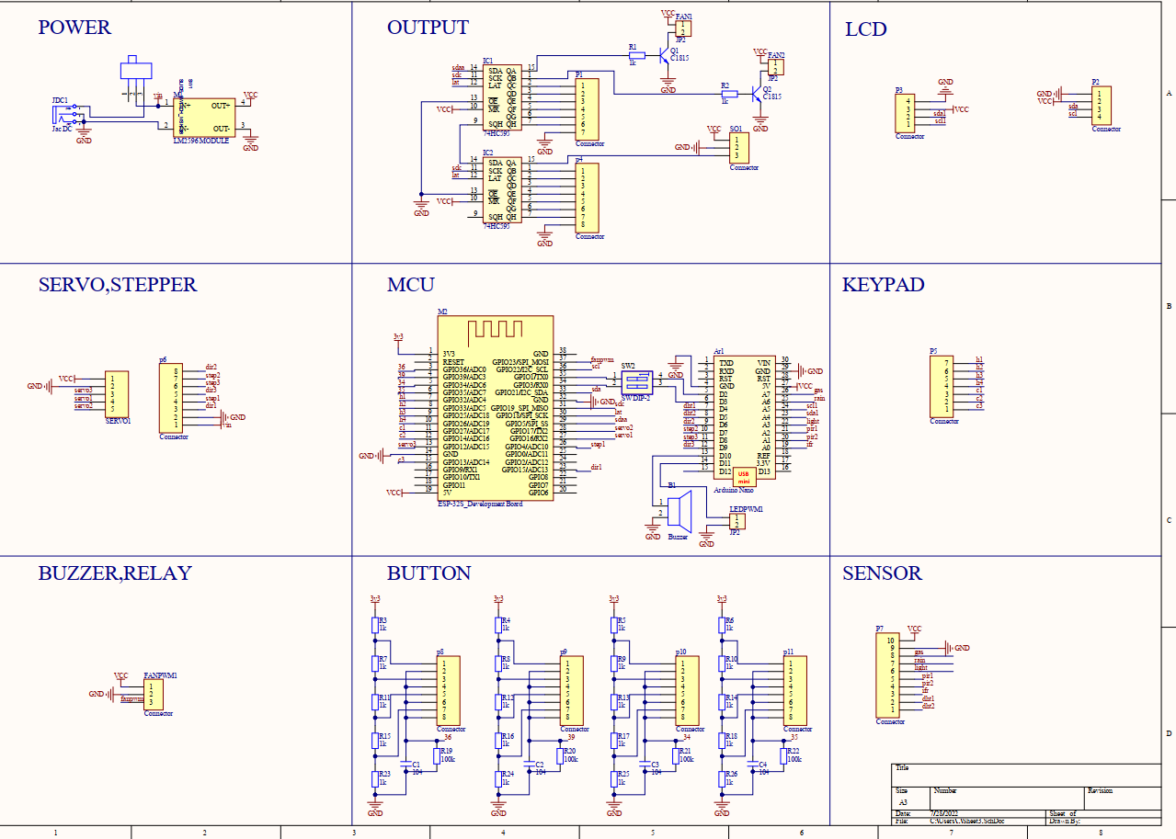

Figure 2. System circuit diagram.

# **CHAPTER 3: MICROPROCESSORS – CONTROL BLOCK**

## **Specification**

* The main idea of our project is connecting the sensors value from the sensors and then control the actuators from microprocessors.
* We can control our smart home system both in manual and auto mode (through application).
* In our project we have 2 DHT11 sensor for temperature and humidity data collection, 2 motion sensors (PIR HC-SR501) for detecting activity, 1 rain sensor for clothesline automation system, 1 light sensor for controlling the light in front of smart home, 1 infrared sensor for turning on and off stair lights automatically, 1 Peltier cooling module for the air conditioning part so we need at least 7 digital pins and 1 analog pin.
* And we also have 3 fans, 3 stepper motors and 2 servo motors, buzzers, lights for the actuators block.
* For the display, we use 3 LCD 16x2.
* In this project we chose 1 Arduino Nano and 1 Node MCU ESP32 chips because:
* ESP32 for the remote control part from the Blynk application because ESP32 has Wi-Fi application
* Enough I/O pins
* Platform and libraries support (Arduino, Blynk, ...)
* Low price
* Easy to program
* We are familiar with

## **Introduction of Arduino Nano**

### **Overview**

Arduino has been and is being used very widely around the world, and is increasingly proving their power through countless unique user applications in the open-source community. However, in Vietnam Arduino is still not well known.

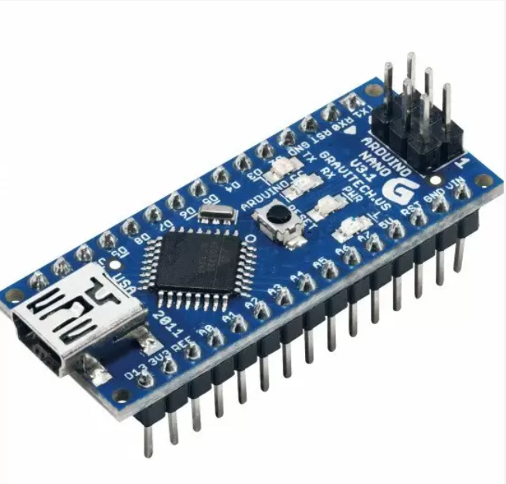

Figure 3. Arduino nano

Arduino is essentially an open-source electronics prototyping platform made up of both hardware and software. Technically, the Arduino can be thought of as a programmable logic controller. Simply put, an Arduino is a device that can interact with the environment through pre-programmed sensors and behaviors. With this device, assembling and controlling electronic devices will be easier than ever. It is not easy for those who are passionate about technology and cybernetics but are outsiders and do not have much time to learn more about programming and mechatronics techniques.

Currently there are many types of microcontrollers and most of them are programmed in C/C++ or Assembly language, so it is difficult for people with little in-depth knowledge of electronics and programming. It is an obstacle for everyone who wants to create their own technological item. That's why Arduino was developed to simplify the design and assembly of electronic components as well as programming on the microprocessor and make it easier for people to access electronic devices without needing to do so. much about electronic knowledge and time. Here are the strengths of Arduino compared to other microcontroller platforms:

* Running on multiple platform: Arduino programming can be implement by many different operating systems such as Windows, Mac Os, Linux on Desktop, Android on mobile.
* Simple programming language that is easy to understand.
* Open platform: Arduino is developed based on open source, so the software running on Arduino is easily shared and integrated into different platforms.
* Hardware expansion: Arduino is designed and used in a modular form, so it is easier to expand the hardware.
* Simple and fast: Very easy to assemble, program and use the device.
* Easy to share: People can easily share source code with each other without worrying about the language or operating system they are using.

Arduino is chosen as the processing brain of many devices from simple to complex. Among them are a few applications that really prove the superiority of the Arduino due to their ability to perform many very complex tasks. The following is a list of some outstanding applications of Arduino such as in 3D printing technology, a robot that tracks the direction of a heat source, creates a device that blinks with sounds and laser lights or as a device for customers. know when the bread comes out.

### **General structure**

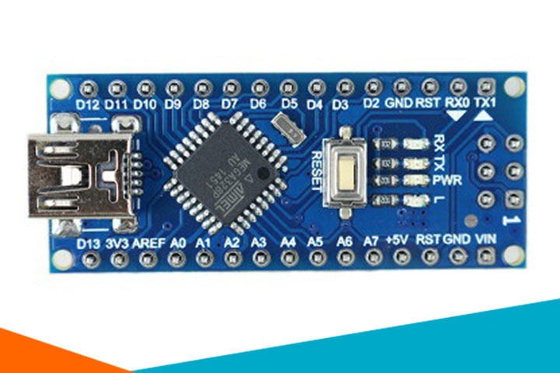

Figure 3. Hardware Architecture of Arduino Nano

The Arduino Nano is a microcontroller board based on the Atmega328 chip. It has 14 digital I/O pins, 8 analog Pins, 2 reset pins and 6 can be used for pulse width modulation. There are 6 analog input pins that allow us to connect external sensors to collect data, using a 16MHz frequency quartz oscillator, there is a USB connection port to We load the program into the board and a power supply pin for the circuit, an ICSP header, a reset button. It contains everything needed to support the microcontroller, power supply to the Arduino can be from the computer via the USB port or from a dedicated power supply converted from AC to DC or a power supply. taken from the battery.

### **Source block**

The Arduino can be powered via a USB connection or with an external power supply. The power source is selected automatically. The microcontroller system can be operated by an external supply from 6V to 20V. However, if supplied with less than 7V, the 5V pin may supply less than 5V and the microcontroller system may be unstable. If more than 12V is supplied, the voltage regulator may overheat and endanger the board. Recommended range is 7V to 12V.

* Pin Vin: Arduino input voltage when we use an external power source (different from 5V source taken from USB or power through a separate power jack). We can supply power through this pin.
* 5V pin: Provides power to the microcontroller and other components on the board and provides power to peripheral devices when connected to the board.
* 3.3V pin: Provides power for sensor devices.
* GND pin: Ground pin.
* Aref pin: Analog input voltage reference.
* IOREF pin: Provides voltage for the microcontroller to operate. A properly configured shield can read the IOREF pin voltage and select the appropriate source or trigger the voltage converter to work at 5V or 3.3V.

### **Memory**

Atmega328 chip has 32KB (with 0.5KB used for bootloader). It also has 2KB SRAM and 1KB EEPROM.

### **Specifications**

Arduino Nano pinout contains 14 digital pins, 8 analog pins, 2 reset pins & 6 power pins

The digital pins we can configure to be input pins from peripheral devices or as pins to transmit signals to peripheral devices. By using pinMode(), digitalWrite() and digitalRead() functions. Each pin can supply or receive a maximum current of 40mA and has an internal pull-up resistor (unconnected by default) of 20 - 50 kOhms. There are also some pins with special functions:

* Pins 1, 2: Serial pins (These two pins receive RX and transmit TX are used for TTL serial data transmission. The RX and TX pins are connected to the corresponding pins of the USB to TTL serial chip)
* Pins 6, 8, 9, 12, 13 and 14: PWM pin (Each of these digital pins provides an 8-bit pulse width modulated signal. The PWM signal can be generated using the analogWrite() function)
* Pins 5, 6: Interrupt (When we need to provide an external interrupt to the processor or other controller, we can use these pins. These pins can be used to enable interrupts INT0 and INT1 respectively using the attachInterrupt() function. The pins can be used to trigger three types of interrupts such as interrupt on low, increase or decrease interrupt level and change interrupt value)
* Pins 13, 14, 15 and 16: SPI communication (When you don't want the data to be transmitted asynchronously, you can use these serial peripheral pins. These pins support synchronous communication with SCK. Although the hardware has this feature, the Arduino software does not. So you have to use SPI library to use this feature)
* Pin 16: Led (When you use pin 16, the onboard led will light up)
* Pins 18, 19, 20, 21, 22, 23, 24, 25 and 26 : Analog I/O (As mentioned earlier the UNO has 6 analog input pins but the Arduino Nano has 8 analog inputs (19 to 26), marked A0 to A7. This means you can connect up to 8 analog input channels for processing. Each of these analog pins has a 1024 bit resolution ADC (so it will give 1024). By default, the pins are measured from ground to 5V. If you want the reference voltage to be 0V to 3.3V, a 3.3V source can be connected to the AREF pin (18th pin) using the analogReference() function. Similar to the digital pins in the Nano, the analog pins also have a number of other functions)
* Pins 23, 24 like A4 and A5: standard I2C . communication (When SPI communication also has its disadvantages such as needing 4 pins and limited to one device. For long distance communication, it is necessary to use the I2C protocol. I2C support with only two wires. One for pulse (SCL) and one for data (SDA). To use this I2C feature, we need to import a library called Wire Library)
* Pin 18: AREF (Reference voltage for input used for ADC conversion)
* Pin 28 : RESET (This is the reset pin of the circuit when we press the button on the board. Usually used to be connected to switches to use as reset button)

## **Node MCU ESP32**

### **What is ESP32**

ESP32 is a low-cost System on Chip (SoC) Microcontroller from Espressif Systems, the developers of the famous ESP8266 SoC. It is a successor to ESP8266 SoC and comes in both single-core and dual-core variations of the Tensilica’s 32-bit Xtensa LX6 Microprocessor with integrated Wi-Fi and Bluetooth.

Like ESP8266, the advantage of ESP32 is that it has integrated RF components such as a power amplifier, low-noise receiver amplifier, antenna switch, filters, and RF balun. Because there are so few additional components needed, it is quite simple to develop hardware around the ESP32.

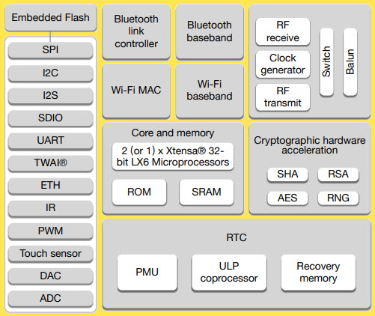

Figure 3. 3 ESP32 Architecture

### **Specifications of ESP32**

ESP32 has a lot more features than ESP8266 and it is difficult to include all the specifications in this Getting Started with ESP32 guide. So, I made a list of some of the important specifications of ESP32 here. But for complete set of specifications, I strongly suggest you to refer to the Datasheet.

* Single or Dual-Core 32-bit LX6 Microprocessor with clock frequency up to 240 MHz.
* 520 KB of SRAM, 448 KB of ROM and 16 KB of RTC SRAM.
* Supports 802.11 b/g/n Wi-Fi connectivity with speeds up to 150 Mbps.
* Support for both Classic Bluetooth v4.2 and BLE specifications.
* 34 Programmable GPIOs.
* Up to 18 channels of 12-bit SAR ADC and 2 channels of 8-bit DAC
* Serial Connectivity include 4 x SPI, 2 x I2C, 2 x I2S, 3 x UART.
* Ethernet MAC for physical LAN Communication (requires external PHY).
* 1 Host controller for SD/SDIO/MMC and 1 Slave controller for SDIO/SPI.
* Motor PWM and up to 16-channels of LED PWM.
* Secure Boot and Flash Encryption.
* Cryptographic Hardware Acceleration for AES, Hash (SHA-2), RSA, ECC and RNG.

### **Different Ways to Program**

A good hardware like ESP32 will be more user friendly if it can be programmed (writing code) in more than one way. And not surprisingly, the ESP32 supports multiple programming environments.

Some of the commonly used programming environments are:

* Arduino IDE
* PlatformIO IDE (VS Code)
* LUA
* MicroPython
* Espressif IDF (IoT Development Framework)
* JavaScript

As Arduino IDE is already a familiar environment, we will use the same to program ESP32 in our upcoming projects. But you can definitely try out others as well.

### **ESP32 DevKit – The ESP32 Development Board**

Espressif Systems released several modules based on ESP32 and one of the popular options is the ESP-WROOM-32 Module. It consists of ESP32 SoC, a 40 MHz crystal oscillator, 4 MB Flash IC and some passive components.

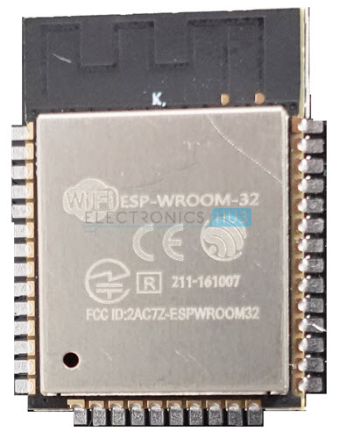

Figure 3. 4 ESP32 DevKit Board

The good thing about ESP-WROOM-32 Module is the PCB has edge castellations. So, what third-part manufacturers do is take the ESP-WROOM-32 Module and design a break-out board for this module.

One such board is the ESP32 DevKit Board. It contains the ESP-WROOM-32 as the main module and also some additional hardware to easily program ESP32 and make connections with the GPIO Pins.

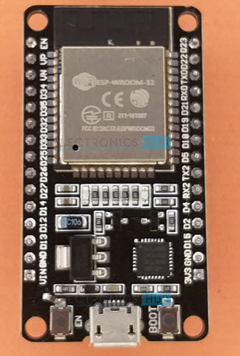

Figure 3. 5 ESP32 Chip Module Board

### **Layout**

We will see what a typical ESP32 Development Board consists of by taking a look at the layout of one of the popular low-cost ESP Boards available in the market called the ESP32 DevKit Board.

The board which I have has 30 Pins (15 pins on each side). There are some board with 36 Pins and some with slightly less Pins. So, double check the pins before making connections or even powering up the board.

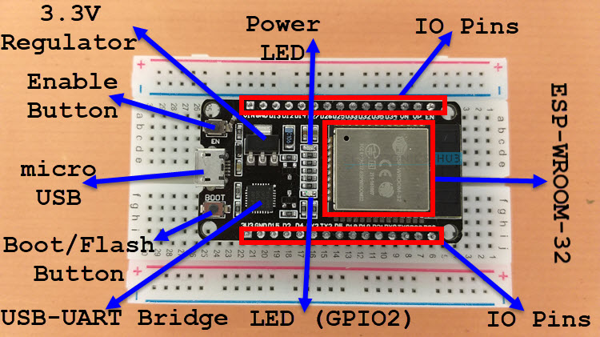

Figure 3. 6 ESP32 Layout

As you can see from the image, the ESP32 Board consists of the following:

* ESP-WROOM-32 Module
* Two rows of IO Pins (with 15 pins on each side)
* CP2012 USB – UART Bridge IC
* micro–USB Connector (for power and programming)
* AMS1117 3.3V Regulator IC
* Enable Button (for Reset)
* Boot Button (for flashing)
* Power LED (Red)
* User LED (Blue – connected to GPIO2)
* Some passive components

An interesting point about the USB-to-UART IC is that its DTR and RTS pins are used to automatically set the ESP32 in to programming mode (whenever required) and also rest the board after programming.

### **Pinout of ESP32 Board**

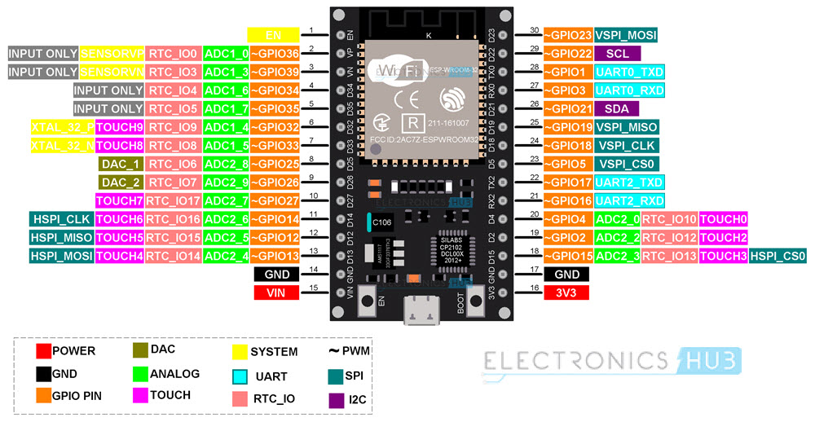

Figure 3. 7 ESP32 pinout

### **Conclusion**

This is a complete beginner’s tutorial on ESP32, an excellent SoC with integrated Wi-Fi and Bluetooth connectivity. You learned about the ESP32 Microcontroller, its specifications, development board layout and a brief pinout as well

# **CHAPTER 4: DESIGN SYSTEM ACTUATORS SYSTEM STRUCTURE FOR SMART HOME**

## **Specification**

* In our project, we focus on some main functions of the smart home system which are the clothesline, curtains, door automation system
* Our idea of the actuators block in this system is just about the simulation model of the clothesline, curtains, and door automation system so from that we can easily understand more about those automation system of smart home in real life. And we decided to choose servo motor SG90, MG996 RC Servo motor, stepper motor 17HS401 which is also easy to use

## **Overview of the devices used in the actuator system**

* 1. **Servo motor SG90**

1. *Pin diagram*

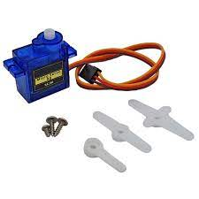

Figure 4. Servo motor S90

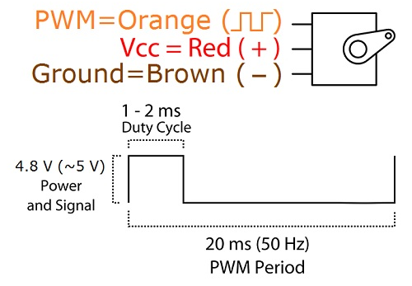

Figure 4. Servo motor S90 pinout

Servo SG90 is a servo motor with 3 pins:

* Orange pin: pulse level
* Red pin: power supply 5V
* Brown pins: ground

1. *Main parameters*

Torque: 1.8kg/cm

Operating speed: 60 degrees in 0.1 seconds

Operating voltage: 4.8V(~5V)

Operating Temperature: 0 C – 55 Cº

1. *Working Principle*

When we supply pulses from 1ms-2ms, we will control the motor to rotate at an angle as desired.

1. *Application in the system*

* Open and close the main door
  1. **5.6V/2.1A DC stepper motor and A4988 control module**

1. *Pin diagram*

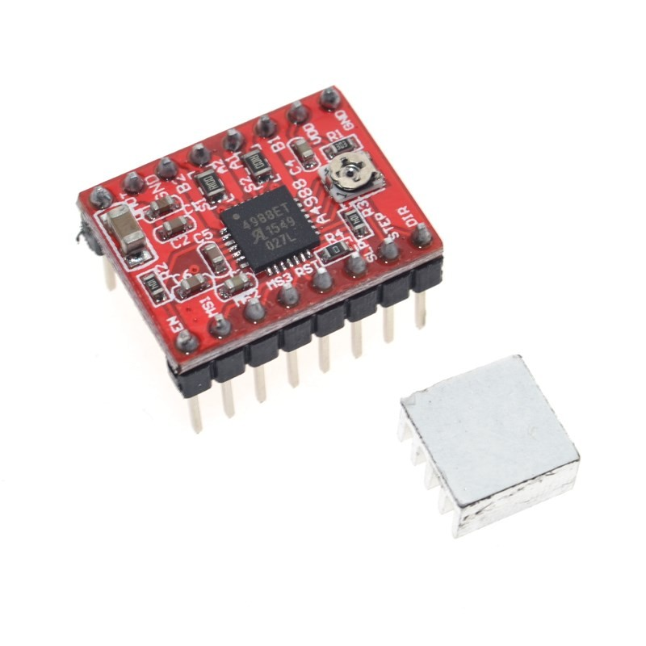

Figure 4. A4988 module

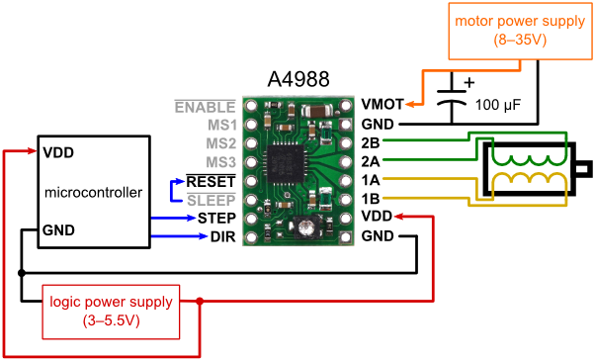

Figure 4. A4988 module pinout

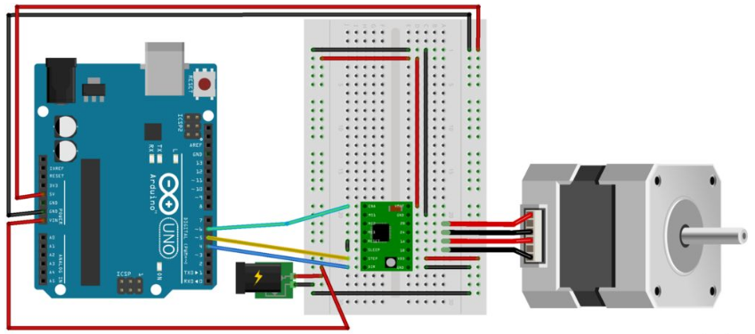

Figure 4. Circuit diagram of stepper DC and A4988

1. *Working Principle*

* The protocol for controlling the number of steps and the direction of rotation is very simple.
* 5 levels of step adjustment: 1; 1/2; 1/4; 1/8 and 1/16 steps.
* Adjust the rated current for the motor by potentiometer.
* Has short circuit protection, over temperature protection, voltage drop protection and reverse current protection.

Turn the motor on and off via the ENABLE pin, the LOW level is on the module, the HIGH level is off

Motor rotation direction control via DIR . battery

Stepper motor control via STEP pin, each pulse corresponds to 1 step (or microstep)

Select the operating mode by setting the logic level for pins MS1, MS2, MS3

The Sleep and Reset pins are connected together.

1. Application in the system

Use as a motor to pull the curtains of the cinema, bedroom, and clothesline.

* 1. **MG996 RC Servo Motor**

1. *Description*

* MG996 RC Servo Motor is the most commonly used in metal robot arm designs. The MG996 RC Servo motor has strong traction, the joints and gears are made entirely of metal, so it is durable, the motor has a built-in driver that controls the motor inside according to the pulse-rotating mechanism, so it is very Easy to use.

1. *Specifications:*

* Type: Analogue RC Servo.
* Operating voltage: 4.8-6.6Vdc.
* Dimensions: 40x19x43mm.
* Weight: 55g.
* Traction:

+ 3.5 kg/cm at 4.8V voltage.

+ 5.5 kg/cm at 6V voltage.

* Spin speed:
* 0.17s/60ºC (4.8V no load).
* 0.13s/60ºC (6.0V no load).

1. *Pins configuration*

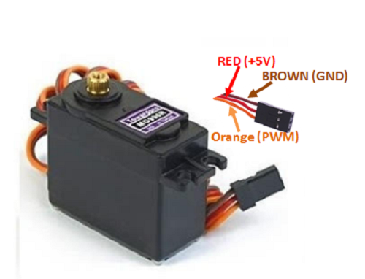

Figure 4. MG996 RC Servo Motor Pinout

|  |  |  |
| --- | --- | --- |
| Number of wire | Color of wire | Description |
| 1 | Brown | This wire connects with Ground of the system |
| 2 | Red | This wire connects with the voltage source (+5V) |
| 3 | Orange | The PWM signal is fed through this wire to control the motor |

Table 4. MG996 RC Servo Motor pinout description

1. *Application of the system*

* Open and close the garage
  1. **Stepper motor Size 42 17HS8401**

1. What is Stepper motor

* Stepper motor is a type of electric motor that converts electrical energy into mechanical energy. Used to convert control signals in the form of discrete electrical pulses consecutively into angular motions. This motion can be linear or angular.

1. Picture of Stepper motor 17HS8401

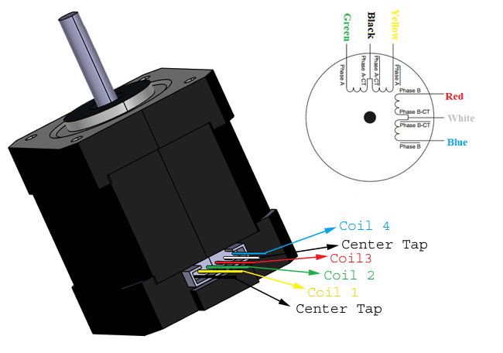

Figure 4. Stepper motor 17HS8401

1. Specifications

|  |  |
| --- | --- |
| Product Name | 40BYGH48P170 |
| Size | 42*42*48MM |
| Phase | 2 |
| Step Angle | 1.8° |
| Shaft | “D” 5MM |
| Outlet way | “4” plug line |
| Color | Silver + black |

Table 4. Stepper motor 17HS8401 specification

## **Device modules used in model and function**

### **Garden and periphery**

1. *Function*

* The door light automatically turns on when someone is in front of the door, turns off 3 seconds after the person leaves.
* Security by Passcode, when entering the wrong password 3 times, the buzzer will sound an alarm.

1. *Processor*

* 1 Arduino nano board: Receives and processes signals from sensors and executes programmed commands for sensors and devices mounted on the board.

1. *Executive structure*

* 1 motion sensor at the gate, when it detects someone appears, the light will light up, automatically turn off when the person leaves after 3 seconds.
* 1 Passcode 4x4 mounted at the door with a 4-pin password. If the password is correct, the door will open

1. Flowchart

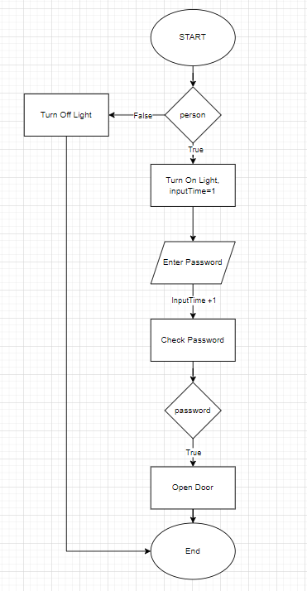

Figure 4. Flowchart of garden and periphery system

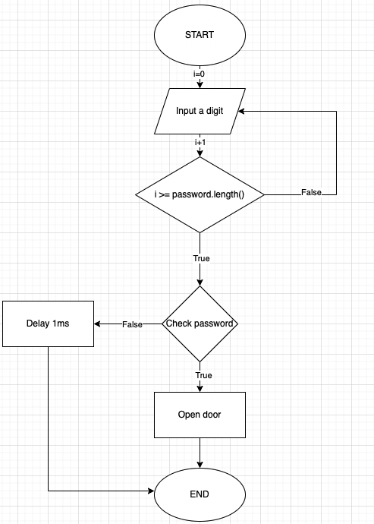

Figure 4. Flowchart of the password system

### **Living room**

1. *Function*

* Open the door automatically when entering the correct password, or use the door opening function on the phone app.
* Lights and fans automatically turn on when someone enters.
* Notification of current temperature and humidity in the house.
* Alarm when the room temperature rises above the specified level.
* The stairs light automatically turns on when someone passes, turns off automatically after 3 seconds.

1. *Processor*

* 1 Arduino nano board: Receives, processes signals from sensors and executes programmed commands for sensors and devices mounted on the board.
* 1 MCU board ESP32: Receive and process signals from devices on other nano boards and send data to the phone application.

1. *Executive structure*

* 1 servo motor is responsible for opening and closing the main door when receiving a signal from the Arduino Nano and responding when entering the correct password or opening the door command from the phone application.
* 1 infrared sensor on the stairs, when detecting someone entering the house, it will automatically turn on the lights and fans.
* The buzzer will sound an alarm when the room temperature rises above the specified limit.
* Keypad and screen enter the password, when the user enters the correct code, the servo motor will rotate and open the door.
* 1 DHT11 temperature and humidity sensor, and 1 LCD screen: the indoor temperature and humidity will be monitored by the sensor and the parameters will be displayed on the LCD screen.
* 4 buttons to turn ON/OFF the light, the fan, OPEN/Close the door, and RAISE/UNRAISE alarm

1. *Flowchart*

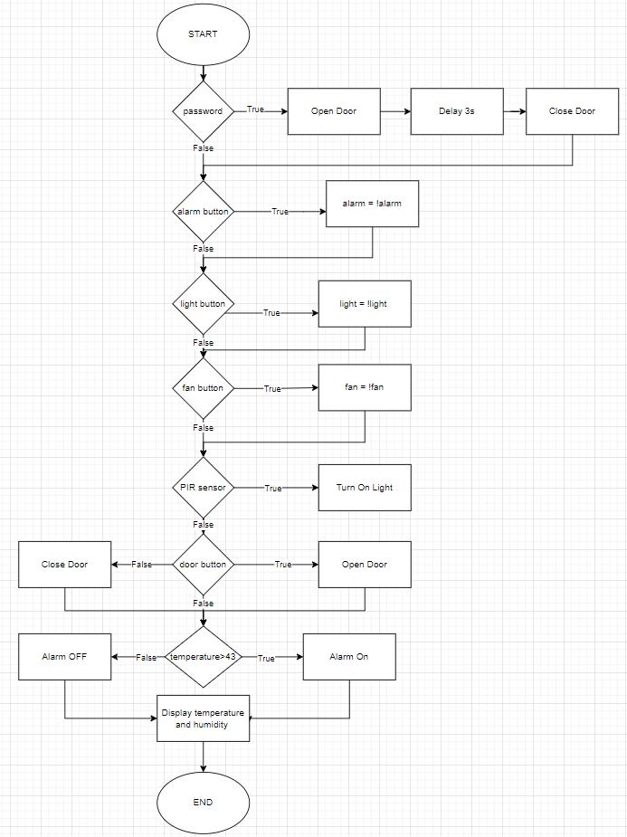

Figure 4. Flowchart of the living room

### **Parking garage**

1. *Function*

* Open and close the door through Blynk application.

1. *Processor*

* Share Arduino Nano board with living room: Receive, process signals from sensors and execute programmed commands for sensors and devices mounted on the board.

1. *Executive structure*

* 1 stepper motor with garage door opening/closing function

### **Sleeping room**

1. *Function*

* Curtains system open and close by manual button or control it directly through the phone interface.
* Display of temperature and humidity through LCD screen.
* Automatically adjust the temperature by Peltier Cooling Module

1. *Microprocessor*

* 1 Arduino nano board: Receives and processes signals from sensors and executes programmed commands for sensors and devices mounted on the board.

1. *Execution structure*

* 1 stepper motor and gear-belt system to pull the curtain open/close and 1 light sensor to control the motor to open and close the curtain by control signal. Curtains can be controlled open and closed via the phone interface.
* 1 Peltier cooling module with the cooling system is controlled via a stepper motor, thereby helping to adjust the room temperature automatically.
* 1 DHT11 temperature sensor and 1 LCD screen: the room temperature will be monitored by the sensor and the parameters displayed on the LCD screen; Peltier Cooling Module will adjust the room temperature.

1. *Flowchart*

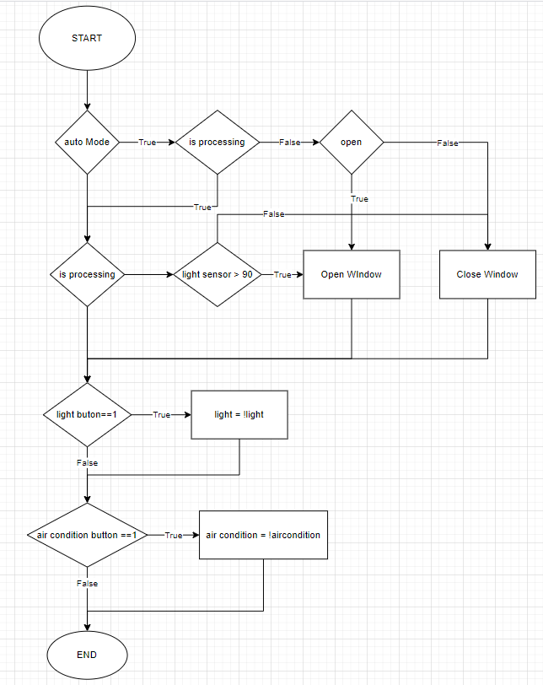

Figure 4. Flowchart of the bedroom

### **Entertainment/movie room**

1. *Function*

* Private movie mode: When selected will turn on the projector, fan and turn off the lights, draw the curtain.

1. *Processor*

* 1 Arduino nano board: Receives and processes signals from sensors and executes programmed commands for sensors and devices mounted on the board.

1. *Executive structure*

* Stepper motor and gear-belt system pull the curtain open/close, controlled through a button. If the curtains are closed, then turn on the TV and if the curtains is opened, then close turn off the TV.
* Fan and lights are controlled through Blynk application.

1. *Flowchart*

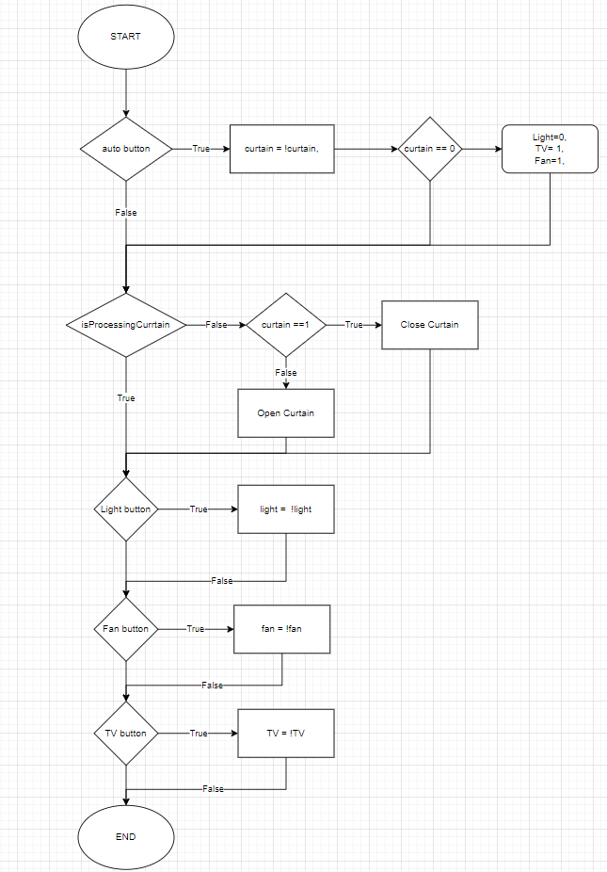

Figure 4. Flowchart of the entertainment room

### **Kitchen**

1. *Function*

* Warn when there is an intruder through the window.
* Alarm when the temperature rises above the specified level.
* Alarm when the gas concentration exceeds the specified level.
* The clothesline automatically retracts when it rains.

1. *Processor*

* 1 Arduino uno R3 board: Receives, processes signals from sensors and executes programmed commands for sensors and devices mounted on the board.

1. *Executive structure*

* A stepper motor and rain sensor are located outside the kitchen wall, which is responsible for pulling the clothesline into the eaves when it rains.
* Fans and lights with controllability via phone app.
* The motion sensor located near the window has the function of sending a signal to the circuit board to turn on the alarm when it detects an intrusion.
* MQ2 gas sensor: an alarm will sound when the gas concentration parameter from the MQ2 sensor exceed the specified level.

1. *Flowchart*

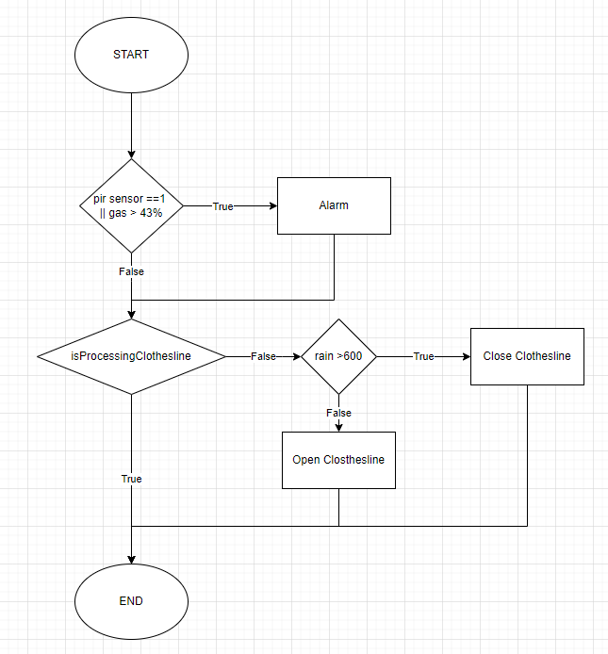

Figure 4. Flowchart of the kitchen

# **CHAPTER 5: ELECTRONIC COMPONENTS, DESIGN MONITORING AND ALARM SYSTEM FOR SMART HOME**

## **Specification**

* We have some other ideas which are collecting the temperature and humidity of our home so that we used DHT11 sensor for simulation model
* Peltier cooling module for the air conditioning system
* Rain sensor for the clothesline automation system
* Motion sensor for anti – theft system
* Infrared sensor for identifying human goes upstairs and then turn on and off the lights
* Light sensor for control lights
* Keyboard for the security in the living room
* LCD for display

## **Electric components and overview of sensors used in monitoring and warning systems**

### **Temperature and humidity sensor DHT11**

1. *Pinout Diagram:*

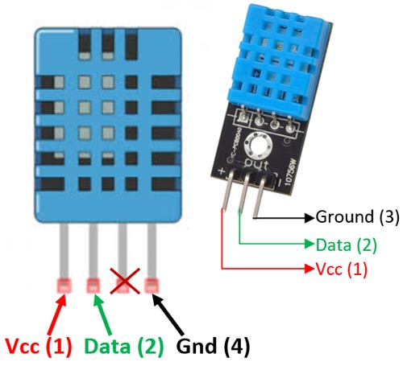

Figure 5. DHT11 sensor pinout

The DHT11 is a basic, low cost digital temperature and humidity sensor.

The DHT11 is a commonly used Temperature and humidity sensor that comes with a dedicated NTC to measure temperature and an 8-bit microcontroller to output the values of temperature and humidity as serial data.

|  |  |  |
| --- | --- | --- |
| **No:** | **Pin Name** | **Description** |
| **For DHT11 Sensor** | | |
| 1 | Vcc | Power supply 3.5V to 5.5V |
| 2 | Data | Outputs both Temperature and Humidity through serial Data |
| 3 | NC | No Connection and hence not used |
| 4 | Ground | Connected to the ground of the circuit |
| **For DHT11 Sensor module** | | |
| 1 | Vcc | Power supply 3.5V to 5.5V |
| 2 | Data | Outputs both Temperature and Humidity through serial Data |
| 3 | Ground | Connected to the ground of the circuit |

Table 5. DHT11 pinout description

1. *DHT11 Specifications:*

* Operating Voltage: 3.5V to 5.5V
* Operating current: 0.3mA (measuring) 60uA (standby)
* Output: Serial data
* Temperature Range: 0°C to 50°C
* Humidity Range: 20% to 90%
* Resolution: Temperature and Humidity both are 16-bit
* Accuracy: ±1°C and ±1%

1. *Working principle of temperature sensor DHT11*

* To be able to communicate with DHT11 according to the standard 1-pin microprocessor, follow 2 steps:
* Send signal you want to measure (Start) to DHT11, then DHT11 confirm again.
* Once communicating with the DHT11, the Sensor sends back 5 bytes of data and the measured temperature.

1. *Application of temperature and humidity sensors in the system*

The temperature and humidity signals collected from this sensor will be applied in monitoring temperature and humidity, automatically disabling when the measured temperature value is greater than the pre-set value. In addition, the signal from this sensor will be used to turn on the siren when the temperature exceeds a certain level. The collected temperature will be continuously sent to the phone application for users to monitor.

### **Gas sensor MQ2**

1. *Introduction of MQ2 gas sensor module*

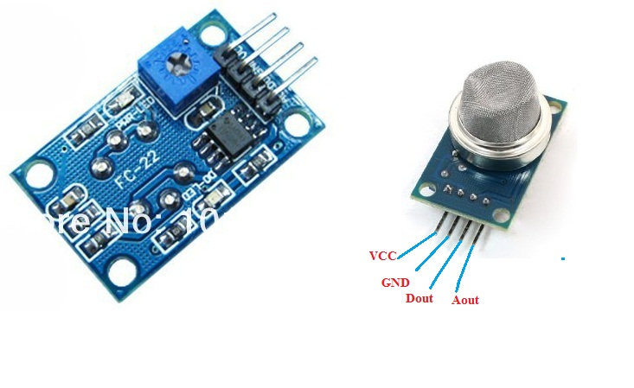

Figure 5. MQ2 gas sensor module

Gas sensor module.

* Operating voltage 3 – 5 volts.
* Connect 4 pins to 2 power supply pins (VCC and GND) and 2 output signal pins.
* Supports both analog and TTL outputs. Analog output 0 – 4.5V proportional to gas concentration, low level active TTL input.

MQ2 is a gas sensor, used to detect potentially flammable gases. It is composed of the semiconductor SnO2. This substance has a low sensitivity to clean air. But when in the environment there is a combustible substance, its conductivity changes immediately. It is thanks to this feature that a simple circuit is added to convert from this sensitivity to voltage.

When the environment is clean, the output voltage of the sensor is low, the output voltage value increases as the concentration of combustible gas around the MQ2 sensor is higher nMQ2 sensor works very well in liquefied petroleum gas, H2, and other combustible gases. It is widely used in industry and civil because of its simple circuit and low cost.

MQ2 works very well in liquefied petroleum gas, H2, and other combustible gases. It is widely used in industry and civil because of its simple circuit and low cost.

1. *Structure diagram and working principle of the module*

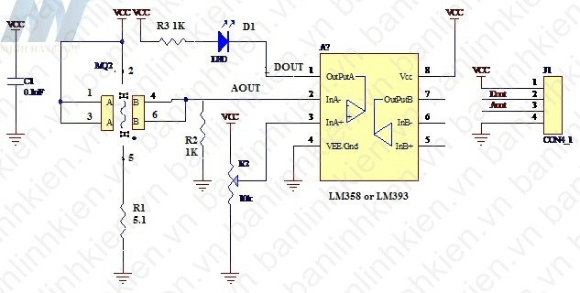

Figure 5. Structure of the MQ2 gas sensor module

MQ2 is a gas sensor, used to detect potentially flammable gases. It is composed of the semiconductor SnO2. This substance has a low sensitivity to clean air. But when in the presence of flammable substances, its conductivity changes immediately. It is thanks to this feature that a simple circuit is added to convert this sensitivity to voltage. When the environment is clean, the output voltage of the sensor is low, the output voltage value increases as the concentration of MQ2 ambient flammable gas is higher.

When detecting a gas leak, the module will output a signal in two forms: DOUT digital and AOUT_analog. Users can choose the appropriate signal depending on the purpose of use.

The circuit has two output pins, Aout and Dout. In there:

* About: analog output voltage. It runs from 0.3 to 4.5V, depending on the ambient gas concentration MQ2.
* Dout: digital output voltage, value 0 or 1 depends on reference voltage and gas concentration measured by MQ2.

Having a digital output pin Dout is very convenient for us to have simple applications, without the need for a microcontroller. Then we just need to adjust the variable resistor value to the concentration value we want to warn. When the measured MQ2 concentration is lower than the allowable level, then Dout = 1, the buzzer will stay in standby state. When the measured flammable gas concentration is greater than the allowed concentration, the Dout =0, the buzzer will sound.

We can connect to the Relay circuit to control turning on and off lights, horns, or other warning devices.

One difficulty when working with MQ2 is that it is difficult to convert the Aout voltage to the ppm concentration value. Then from there display and alert in ppm. Because the return voltage value of each gas is different, it is also affected by temperature and humidity.

In your device, you can define the alarm point manually:

* First measure the clean air state, the obtained value Vout1.
* Let the gas from the lighter leak out. We see the Aout value increase. When the gas distance from the lighter is reasonable and corresponds to the dangerous starting gas concentration, we record the value Vout2. We choose the value Vout2 as the alarm threshold value. If the measured value is larger, we will warn you.
* Adjust the rheostat so that the voltage measured at pin 3 of L358 = Vout2.

1. *Application of the module*

Gas sensors have great applications in life:

* Detecting gas leaks in the water.
* In industry used to detect flammable substances.
* Flammable gas detector.

### **Motion sensor HC-SR510**

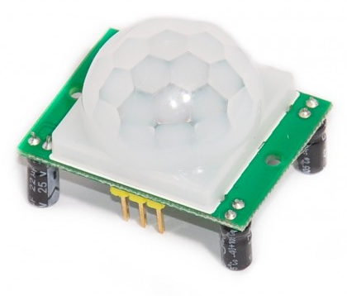

Figure 5. Motion sensor module HC-SR510

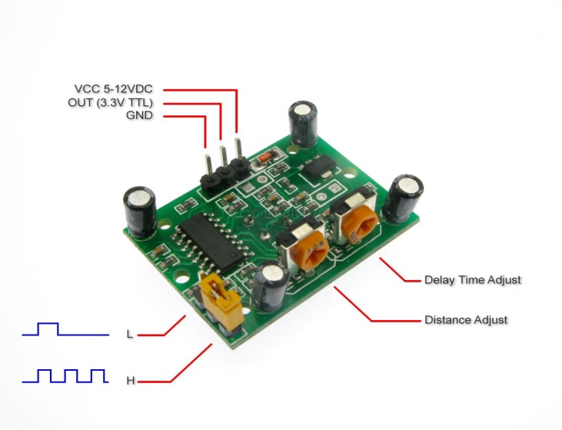

Figure 5. HC-SR510 motion sensor input

1. *Specifications:*

* Voltage usage: 4.5-20V
* Output voltage: 0-3.3V
* Pins: Vcc, OUT, GND.
* 2 operating modes
  + (L) no repeat activation
  + (H) repeat activation.
* Delay time: adjustable between 0.5-200S.
* PCB Size:32mmx24mm
* Scan angle <100 degrees.
* Using sensor: 500BP
* Detection distance: 2-4.5m

1. *The working principle of the module*

Working mechanism of infrared sensor PIR: is a sensor that receives infrared rays emitted from infrared-emitting objects such as the human body (or any heat source).

PIR sensors always have a sensor (sensor eye) with 2 units (element). In front of the sensor is a prism (usually made of plastic), made in the style of a fresnel prism. This fresnel prism has the effect of blocking and dividing into many zones (zones) that allow infrared rays to enter the sensor's eyes. Without the fresnel prism, all the radiation of the medium would be treated as if there was only one zone bouncing off the sensor's eyes, so it would have no motion discrimination effect, and would be extremely sensitive to any disturbances. any change in the temperature of the environment.

2 units of the sensor eye have the effect of dividing into 2 electrodes. One is positive (+) and the other is negative (-). When these two units are sequentially activated (one is done, then the other) is generated an electrical pulse, which activates the sensor. Because of this principle, when someone walks in a direction perpendicular to the sensor's control area (arrow direction), body temperature from this person (infrared radiation) will in turn activate each sensor unit and make alarm sensor.

1. *Application of the module*

This module is used to detect motion in its workspace. Thanks to this function, it can be used to detect motion when there is an intruder in the window or the back door of the kitchen.

### **IR Infrared Obstacle Avoidance Sensor Module**

1. *Descriptions*

* The infrared obstacle sensor is adaptable to the environment, having a pair of infrared transmitters and receivers. Infrared rays emit a certain frequency, when detecting the direction of transmission with obstacles (reflective surface), reflected into the infrared receiver lamp, after comparison, the blue light will light up, at the same time the signal will be sent to the receiver. output signal (a low-order signal).
* Effective working distance 2~5cm, working voltage is 3.3V to 5V. The light sensitivity of the infrared obstacle sensor is adjusted by the potentiometer, the sensor is easy to assemble, easy to use, etc.

1. *Specifications*

* Comparator using LM393, stable working
* Working voltage: 3.3V – 5V DC.
* When the power is on, the red power indicator light is on.
* 3mm screw hole, easy to fix, install.
* Size: 3.2cm * 1.4cm
* The module has been compared the threshold voltage through the potentiometer, if used in common mode, please do not arbitrarily adjust the potentiometer.

1. *Diagram*

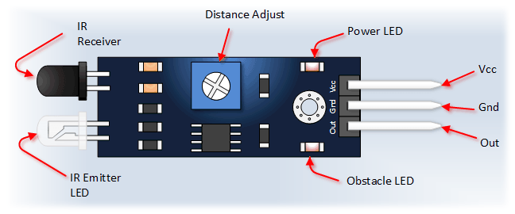

Figure 5. Diagram of IR Infrared Obstacle Avoidance Sensor Module

* Pins
* VCC: 3.3V to 5V conversion voltage (can be directly connected to 5V and 3.3V microcontrollers)
* GND: External GND
* OUT: digital output (0 and 1)

### **Light Sensor**

1. *Descriptions*

* The light sensor module is an electronic component whose resistance varies with the light entering it. The photoresistor is made of a high impedance semiconductor and has no junctions. In the dark, photoresistors have resistances up to several MΩ. When there is light, the resistance drops to a few hundred Ω Accuracy: ±5%RH and ±2o
* The operation of photoresistors is based on the photoelectric effect in the mass of matter. When a photon with enough energy hits it, it knocks electrons out of the molecule, becomes free in the mass, and makes the semiconductor a conductor. The degree of electrical conductivity depends on the number of photons absorbed.

1. *Specifications*

* Operating voltage: 3.3V-5V
* PCB Size: 3cm*1.6cm
* Green LED indicates power and light
* Comparator IC: LM393
* VCC: 3.3V-5V
* GND: 0V
* DO: Digital signal output (0 and 1)
* AO: Analog Output (Analog signal)

1. *Pinout*

* AO: Analog signal
* DO: Digital output signal
* GND: Connect Mass- Cathode
* VCC: Connect 3.3V to 5V

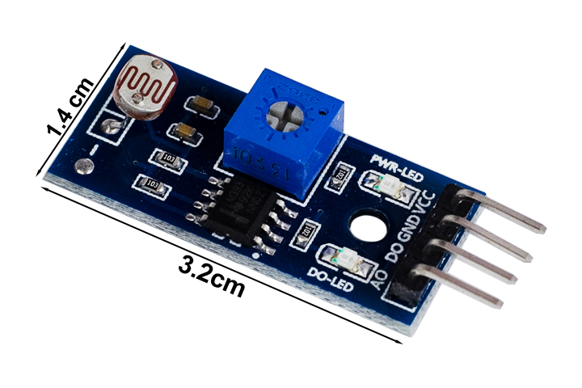

Figure 5. Light sensor pinout

1. *Principle diagram*

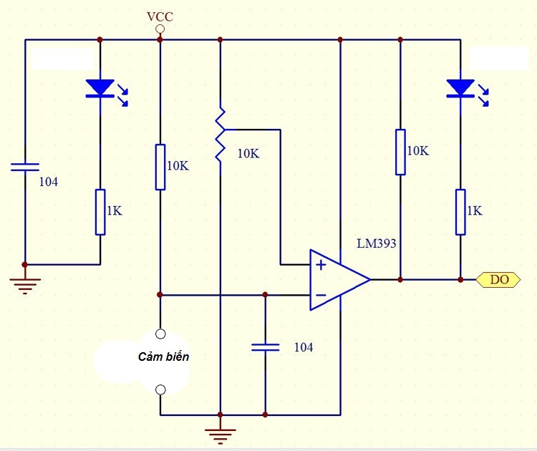

Figure 5. Light sensor principle diagram 1

* The light sensor module has 2 output signals D0 and A0, the output A0 is taken from the photoresistor and put into the comparator lm393 to give 0V and 5V voltage levels. The rheostat adjusts the sensitivity of the sensor, you can optionally change the rheostat so that the sensor outputs level 1 with the appropriate light intensity.

1. *Application*

* Manufacture automatic night lights, line detectors, measure light intensity.
* Use the digital function to make the lights turn on automatically when it's dar
* The DO output will output level 1 when it's dark, combined with the NPN tran and led lights to make a night light that automatically lights up when it's dark, you can adjust the rheostat to adjust the most suitable light time.

*Principle diagram*

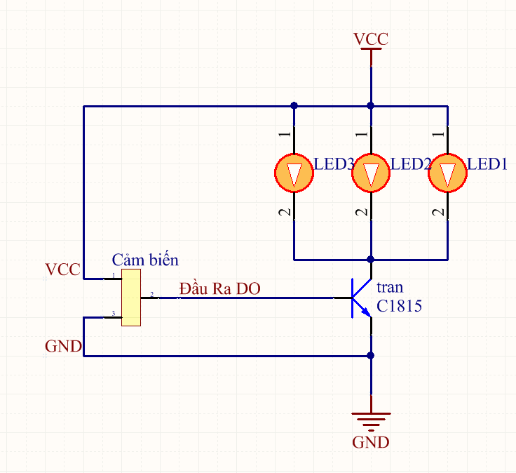

Figure 5. Light sensor principle diagram 2

1. *Working principle*

* When it is dark, the sensor gives a level of 1 to open C1815 and the led lights up.
* When it's bright, the sensor outputs 0 tran C1815 no lead, led off.

### **Rain sensor**

1. *Descriptions*

* Rain sensor is used to detect water level, rain, or watery environments. The rain sensor circuit is placed outdoors to check if it is raining, thereby transmitting the control signal to close / disconnect the relay.
* *The rain sensor circuit consists of 2 parts:*
* Rain sensor mounted outdoors
* The sensitivity regulator needs to be shielded
* The rain sensor circuit works by comparing the voltage of the outdoor sensor circuit with a predetermined value (this value can be changed through a blue rheostat) thereby emitting a signal to turn on / off the relay. le through pin D0.
* When the sensor is dry (it is not raining), the D0 pin of the rain sensor module will be kept high (5V-12V). When there is water on the sensor surface (it is raining), the red LED will light up, pin D0 is pulled low (0V).

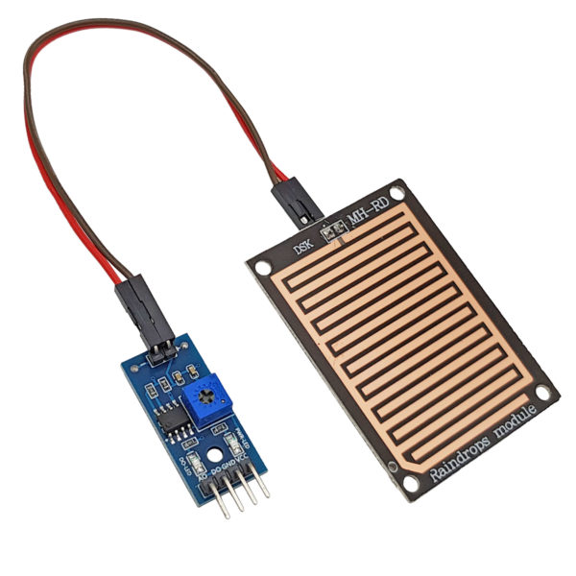

Figure 5. Rain sensor

1. *Specifications*

* Voltage: 5V
* Power LED (Blue)
* Rain warning LED (red)
* Operation is based on the principle: Water falling on the board will create a conductive medium.
* There are two types of signals: Analog (AO) and Digital (DO).
* Signal form: TTL, output 100mA (Can be used directly Relay, Small capacity whistle ...)
* Adjust the sensitivity by rheostat.
* Use LM358 to convert AO -> DO
* Dimensions: 5.4*4.0mm
* 1.6mm thick

### **Peltier Cooling Module**

1. *Descriptions*

* Hot and cold clams, also known as super-technology semiconductor wafers or peltier chips, are semiconductors that have cooling properties on one side, the other side is heated. More specifically, a small, light and powerful semiconductor piece 50W) this helps to absorb heat from the surface with the symbol above and discharge it to the other surface => the amount of heat on the other surface will be equal to the sum of the heat absorbed from the surface with the letter and the amount of heat transferred from the electricity that We put in 2 wires of this piece of semiconductor.
* Therefore, in a cooling application, the better the heat dissipation for the hot side, the colder the other side will be, possibly down to the freezing point and freezing. If you put a large voltage on the two ends of the wire, making the other side very hot without enough heat dissipation, this semiconductor piece (Peltier) will be damaged by overheating.

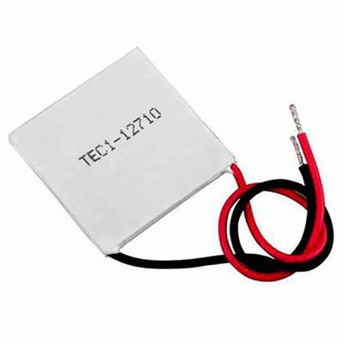

Figure 5. Peltier cooling module

1. *Configuration*

* Both hot and cold clams are composed of 2 sides, a cold side and a hot side, usually fitted with a heat sink and 2 negative and positive power cords.

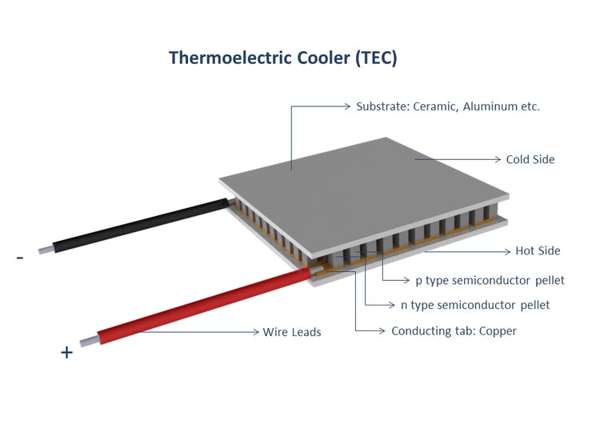

Figure 5. Peltier cooling module configuration

1. *Specifications*

* Size: 4cm x 4cm
* I(A): 5 A -10A (I tested with 10A line, it cools very quickly)
* Voltage: 3 V~ 15.4 V (DC current)
* Cooling power: 50 W, 90 W, 120 W
* 2-sided temperature difference: ~67°C (so the better the heat is dissipated, the colder the cold side)
* Maximum cooling temperature: – 6 °C . (if your heatsink is good)

*There are many types of Peltier Cooling Module with different capacities:*

* TEC1-12705 : Power 50W
* TEC1-12706 : Power 60W
* TEC1-12708 : Power 80W
* TEC1-12710 : Power 100W
* TEC1-12715 : Power 150W

### **Module Relay 12V DC**

1. *Descriptions*

* - High or low level triggers can be configured via a jumper to accommodate more trigger applications.
* With patch optical isolation, strong drive ability and stable performance.
* The module can be high or low by a jumper setting trigger.
* Interface design humane, all interfaces can be connected directly via terminal wiring leads , very convenient.
* Fault-tolerant design , even if the control line is broken , the relay will not operate
* MODULE Relay 2 Channel 12VDC H/L uses 12VDC source to feed the circuit, the trigger signal can optionally trigger a high level (High - 12VDC) or a low level (Low - 0VDC) through the Jumper on each relay. Suitable for devices using 12VDC signal level such as Microcontroller

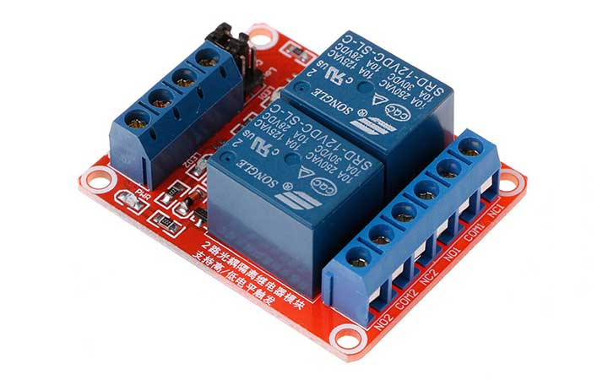

Figure 5. 14 Module Relay 12V DC 2 channels

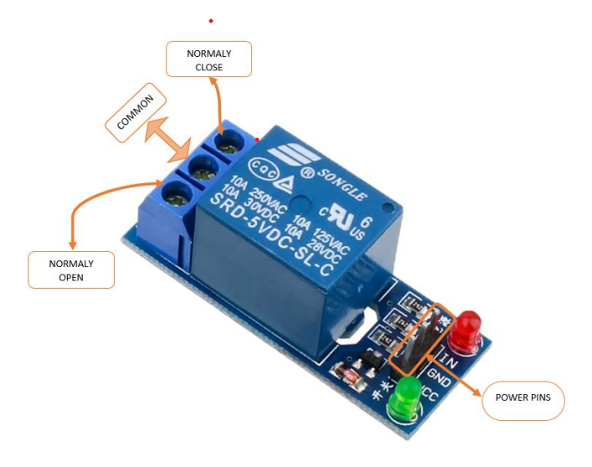

Figure 5. 15 Module Relay 12V DC 1 channel

1. *Specification*

* Maximum load: AC 250V / 10A, DC 30V / 10A
* Trigger current: 5mA
* Working voltage: 12V
* Relay module size: 50 x 26 x 18.5mm (L x W x H)
* Four mounting bolt holes, diameter 3.1mm

1. *Working principle*



Figure 5. 16 Module Relay 12V DC working principle 1

* Relay works on the principle of electromagnetic induction.
* When the electromagnet is applied with some current, it induces a magnetic field around it.
* Above image shows working of the relay. A switch is used to apply DC current to the load.
* In the relay, Copper coil and the iron core acts as electromagnet.
* When the coil is applied with DC current, it starts attracting the contact as shown. This is called energizing of relay.
* When the supply is removed it retrieves back to the original position. This is called De energizing of relay.

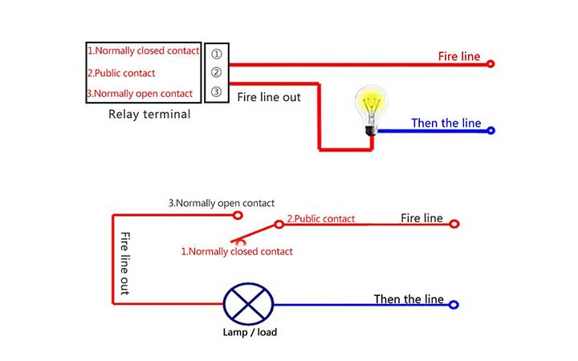

Figure 5. 17 Module Realy 12V DC working principle 2

### **Radiator fan**

1. *Function*

* Radiator fan creates cooling air for electronic devices.

1. *Specifications*

* Power DC5V
* Rated current : 0.1A
* Power: 0.5W
* Number of revolutions: 7000 ± 10% (rpm)
* Noise: 20DBA
* Wind speed: 1.5M/S
* Lifespan: 30,000 hours.
* Dimensions: 3x3x1CM

1. *Picture*

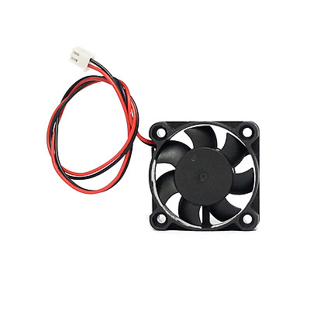

Figure 5. 18 Radiator fan

### **LCD 16x2**

1. *What is LCD 16x2*

* An electronic device that is used to display data and the message is known as LCD 16×2. As the name suggests, it includes 16 Columns & 2 Rows so it can display 32 characters (16×2=32) in total & every character will be made with 5×8 (40) Pixel Dots. So the total pixels within this LCD can be calculated as 32 x 40 otherwise 1280 pixels.

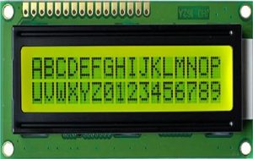

Figure 5. 19 LCD 16x2

* 16 X2 displays mostly depend on multi-segment LEDs. There are different types of displays available in the market with different combinations such as 8×2, 8×1, 16×1, and 10×2, however, the LCD 16×2 is broadly used in devices, DIY circuits, electronic projects due to less cost, programmable friendly & simple to access.

1. *Specifications*

* The operating voltage of this display ranges from 4.7V to 5.3V
* The display bezel is 72 x 25mm
* The operating current is 1mA without a backlight
* PCB size of the module is 80L x 36W x 10H mm
* HD47780 controller
* LED color for backlight is green or blue
* Number of columns – 16
* Number of rows – 2
* Number of LCD pins – 16
* Characters – 32
* It works in 4-bit and 8-bit modes
* Pixel box of each character is 5×8 pixel
* Font size of character is 0.125Width x 0.200height

1. *Pin configuration*

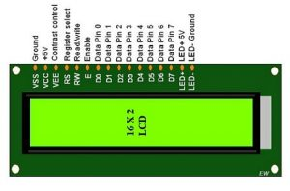

Figure 5. 20 LCD 16x2 pinout

* Pin1 (Ground): This pin connects the ground terminal.
* Pin2 (+5 Volt): This pin provides a +5V supply to the LCD
* Pin3 (VE): This pin selects the contrast of the LCD.
* Pin4 (Register Select): This pin is used to connect a data pin of an MCU & gets either 1 or 0. Here, data mode = 0 and command mode =1.
* Pin5 (Read & Write): This pin is used to read/write data.
* Pin6 (Enable): This enables the pin must be high to perform the Read/Write procedure. This pin is connected to the data pin of the microcontroller to be held high constantly.
* Pin7 (Data Pin): The data pins are from 0-7 which are connected through the microcontroller for data transmission. The LCD module can also work on the 4-bit mode through working on pins 1, 2, 3 & other pins are free.
* Pin8 – Data Pin 1
* Pin9 – Data Pin 2
* Pin10 – Data Pin 3
* Pin11 – Data Pin 4
* Pin12 – Data Pin 5
* Pin13 – Data Pin 6
* Pin14 – Data Pin 7
* Pin15 (LED Positive): This is a +Ve terminal of the backlight LED of the display & it is connected to +5V to activate the LED backlight.
* Pin16 (LED Negative): This is a -Ve terminal of a backlight LED of the display & it is connected to the GND terminal to activate the LED backlight

1. *Working principle*

* The basic working principle of LCD is passing the light from layer to layer through modules. These modules will vibrate & line up their position on 90o that permits the polarized sheet to allow the light to pass through it.
* These molecules are accountable for viewing the data on every pixel. Every pixel utilizes the method of absorbing light to illustrate the digit. To display the value, the position of molecules must be changed to the angle of light.
* So this light deflection will make the human eye notice the data that will be the ingredient wherever the light gets absorbed. Here, this data will supply to the molecules & will be there till they get changed
* At present, LCDs are used frequently in CD/DVD players, digital watches, computers, etc. In screen industries, LCDs have replaced the CRTs (Cathode Ray Tubes) because these displays use more power as compared to LCD, heavier & larger.
* The displays of LCDs are thinner as compared to CRTs. As compared to LED screens, LCD has less power consumption because it functions on the fundamental principle of blocking light instead of dissipating.

1. *Registers of LCD*

* The registers used in LCD are two types like data register & command register. The register can be changed by using the RS pinout. If we set ‘0’ then it is command register and if it is ‘1’ then it is data register.
* *Command Register*
* The main function of the command register is to save instructions illustrated on LCD. That assists in data clearing & changes the cursor location & controls the display.
* *Data Register*
* The data register is used to save the date to exhibit on the LCD. Once we transmit data to LCD, then it shifts to the data register to process the data. If we fix the register value at one that the data register will start working.

### **I2C Communication**

1. *Definition*

* I2C (Inter - Integrated Circuit) is a synchronous serial communication protocol developed by Philips Semiconductors, used to transmit and receive data between ICs using only two signal lines.
* The data bits will be transmitted bit by bit at regular intervals set by a clock signal.
* The I2C bus is often used to interface peripherals for many different types of ICs such as microcontrollers, sensors, EEPROMs, ...

1. *Working principle*

* Structure:
* I2C uses 2 signal lines:

SCL - Serial Clock Line : Generates a clock clock transmitted by the Master

SDA - Serial Data Line : The line to receive data.

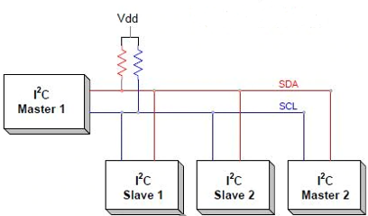

Figure 5. I2C structure

* I2C communication includes the process of transmitting and receiving data between master and slave devices, or Master - Slave.
* The Master device is a microcontroller, it is responsible for controlling the SCL signal line and sending and receiving data or commands through the SDA line to other devices.
* Devices that receive command and signal data from the Master device are called Slave devices. Slave devices are usually ICs, or even microcontrollers.
* Master and Slave are connected together as shown above. The two bus lines SCL and SDA both operate in Open Drain mode, meaning that any device connected to this I2C network can only pull these two bus lines low (LOW), but cannot pull them. to a high level. Because to avoid the case that the bus is both pulled by one device to a high level and by another device to a low level, causing a short circuit. Therefore, a resistor (from 1 to 4.7 kΩ) is required to keep the default high.
* I2C transmission frame:

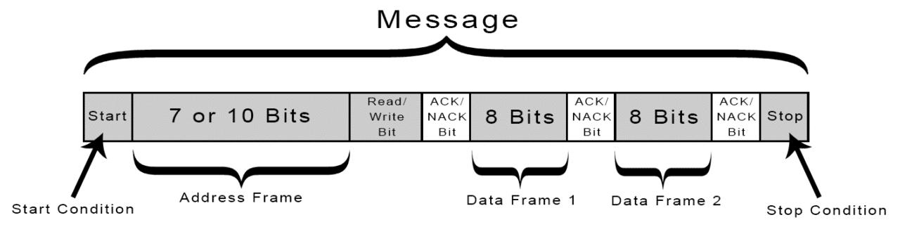

Figure 5. I2C transmission frame

* Address bit block:
* Normally, the transmission process will take place with many devices and ICs together. Therefore, to distinguish these devices, they will be assigned a fixed 7-bit physical address.

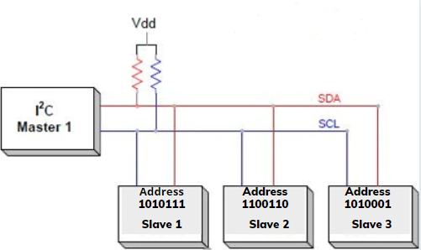

Figure 5. I2C address bit block

* Read/Write Bit
* This bit is used to determine whether the process is transmitting or receiving data from the Master device. If the Master sends data, this bit is equal to '0', and vice versa, receives data when this bit is equal to '1'.
* ACK/NACK Bit
* This bit is used to determine whether the process is transmitting or receiving data from the Master device. If the Master sends data, this bit is equal to '0', and vice versa, receives data when this bit is equal to '1'.
* Data bit block:
* Consists of 8 bits and is set by the sending device to the kernel. After these bits are sent, an ACK/NACK bit is immediately followed to confirm that the receiving device has successfully received the data. If received successfully, the ACK/NACK bit is set to '0' and vice versa.
* Data transmission process:
* Start: The Master device will send a Start pulse by pulling the SDA and SCL lines from 1 to 0.

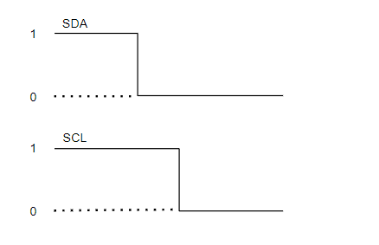

Figure 5. I2C address bit block

* Next, the Master sends the 7 address bits to the Slave that wants to communicate with the Read/Write bit.
* The slave will compare the physical address with the address it was sent to. If there is a match, the slave acknowledges by pulling the SDA line to 0 and setting the ACK/NACK bit to '0'. If there is no match, the SDA and ACK/NACK bits both default to '1'.
* The Master device sends or receives a data bit frame. If the Master sends to the Slave, the Read/Write bit is set to 0. Otherwise, if received, this bit is set to 1.
* If the data frame has been successfully transmitted, the ACK/NACK bit is set to 0 to signal the Master to continue.
* After all data has been successfully sent to the Slave, the Master will issue a Stop signal to notify the Slaves that the transmission has ended by switching SCL, SDA from level 0 to level 1, respectively.
* I2C operating modes:
* Standard mode at 100 kBit/s.
* Low speed mode at 10 kBit/s.

In addition, unlike the SPI interface, which can only have 1 Master, the I2C interface allows data transmission between many different Master devices and Slave devices. However, this process is a bit complicated because the Slave device can receive multiple data frames from different Master devices at the same time, which sometimes leads to collisions or errors in the received data.

To avoid that, when working in this mode, each Master device needs to detect what state the SDA line is in. If SDA is at 0, it means that there is another Master device that has control and must wait until the transmission is complete. Conversely, if SDA is at 1, it means that the SDA line is safe and in use.

1. *Picture*

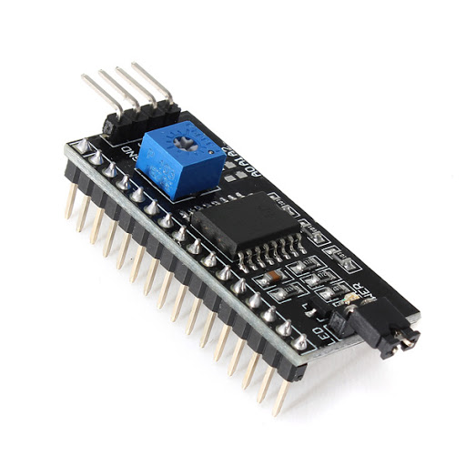

Figure 5. I2C module

### **Keypad 3x4**

1. *Description*

* Punch in your secret key into this numeric matrix keypad. This keypad has 12 buttons, arranged in a telephone-line 3x4 grid. It's made of a thin, flexible membrane material with an adhesive backing (just remove the paper) so you can attach it to nearly anything. The keys are connected into a matrix, so you only need 7 microcontroller pins (3-columns and 4-rows) to scan through the pad

1. *Specifications*

* Weight: 7.5 grams
* Keypad dimensions: 70mm x 77mm x 1mm (2.75" x 3" x 0.035")
* Length of cable + connector: 85mm
* 7-pin 0.1" pitch connector

1. *Picture*

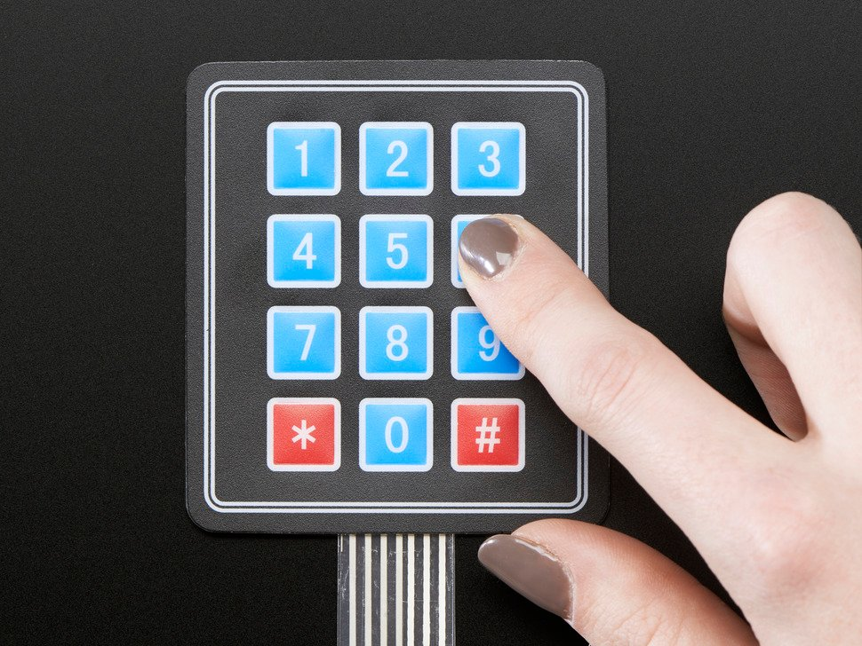

Figure 5. Keyboard 3x4

### **Button**

1. *Specifications*

* Number of pins: 4 pins.
* Current withstanding: 2A.
* Color: black.
* Shape: square.
* Dimensions: 6 x 6 x 12mmt

1. *Working principle*

* When the button is NOT pressed, pin A is NOT connected to pin B
* When the button is pressed, pin A is connected to pin B

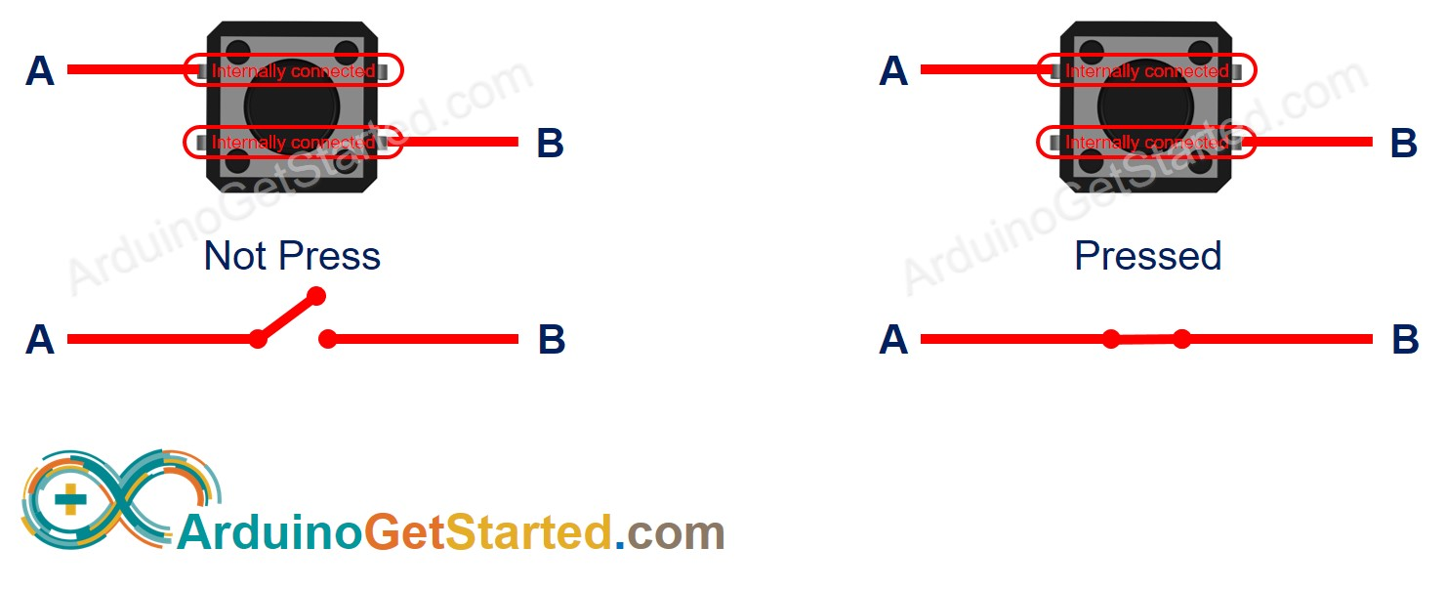

Figure 5. Button working principle

1. *Picture*

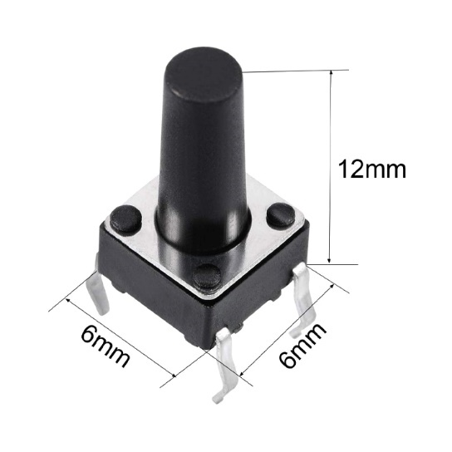

Figure 5. Button

### **Voltage Supply**

1. *12V – 5A Adapter*

* Description
* Power adapter 12V 5A, also known as 12 volt DC power supply, is designed to convert voltage from 110/220VAC AC to 12VDC DC to supply operating equipment. Power adapter 12V 5A used to power camera, hdd box, hdd docking, other electronic equipment...
* Specifications
* Input voltage: AC100-240V 50 / 60HZ
* AC plug: US standard
* Output voltage: DC12V
* Maximum output current: 5A
* Total length of source ~ 1m5
* Efficiency: > 85%
* DC Jack: 5.5*2.5mm (compatible 5.5 * 2.1mm)
* Weight: 215g
* Picture

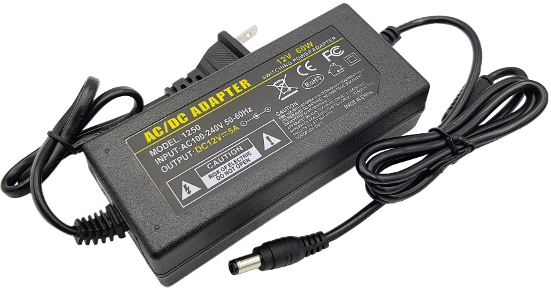

Figure 5. Apdater 12V – 5A

1. *12V – 2A Adapter*

* Description
* Power Adapter has the role of converting AC voltage into DC voltage to serve today's modern technology devices.
* Power Adapter 12V 2A is a kind of pulse source, can convert from 240VAC to 12VDC.
* Specifications
* Classification: Pulse Source
* Input power: 100V- 240VAC
* Output voltage: 12VDC
* Maximum output current: 2A
* AC input: 2-pin AC jack
* Picture

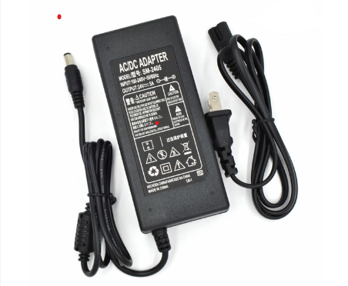

Figure 5. Apdater 12V – 5A

1. Non-Isolation Voltage Supply (5V and 12V)

* Chose an isolation voltage supply without isolation IC DC-DC converter

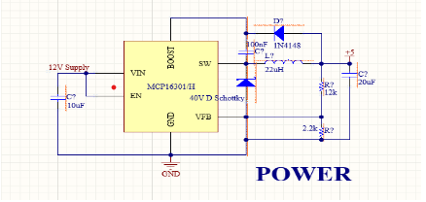

Figure 5. Non-Isolation Voltage Supply

### **IC 74HC595**

1. *Description*

* 74HC595 IC is a 16-pin shift register IC consisting of a D-type latch along with a shift register inside the chip. It receives serial input data and then sends out this data through parallel pins. In addition to parallel outputs, it also provides a serial output. It has independent clock inputs for the shift register and D latch. This IC belongs to the HC family of logic devices which is designed for use in CMOS applications.
* 74HC595 has two built-in registers. The first one is a shift register and the second one is a storage register. Data serially transfers to shift register bit by bit. But it transfers to the storage register only when the data latch pin is active high.

1. *74HC595 Pinout Diagram*

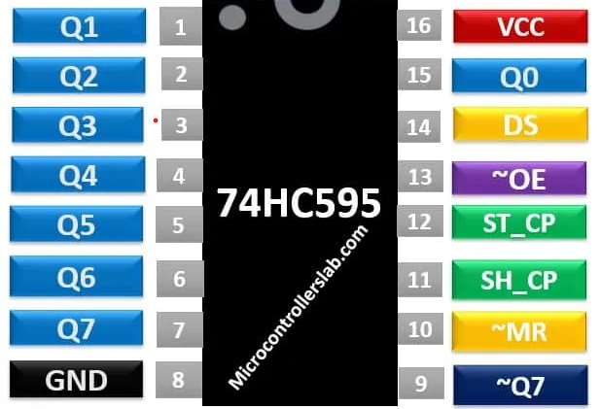

Figure 5. 32 74HC595 pinout diagram

* Pin 01, 02, 03, 04, 05, 06, 07, 15: Output pins

These eight pins are the output pins of the shift register. We should connect these pins with any peripheral where we want to display storage register data. Commonly used components are like LED, seven-segment displays, etc.

* Pin 08: GND

This is the ground pin and is connected to the ground of the circuit.

* Pin 09: Q7’

It is a non-inverted serial data output coming out of the eighth stage of a shift register. It is also used for cascading purposes. For instance, if we need 16 bits shift register. We can daisy-chain two 74HC595 ICs. To do this, simply connect ~Q7 pin with Serial input DS pin of 2nd 595 IC. Moreover, provides the same clock signal to both integrated circuits. In this way, two 74HC595 will work as a single 16-bit shift register. Furthermore, you can continue this process to connect as many ICs as you want to get more data width.

* Pin 10: ~MR

It is an asynchronous, active low master reset Input which is used to reset the shift register only. The 8-bit latch is not affected by this input. Applying a low signal at pin 10 will reset the shift register portion only.

* Pin 11: SH_CP

This is the clock input pin of a 74hc595 shift register. A data is shifted from the serial input pin to the 8-bit shift register on every positive transition of the clock signal applied at this pin.

* Pin 12: ST_CP

This is the active high, clock input pin of a storage register. A positive transition of a signal at this pin is used to update the data to the output pins.

* Pin 13: ~OE

The Output Enable pin is active low. When this pin is low, the data in the storage register appears at the output. On applying high signals, outputs are turned off by forcing them into the high-impedance state. However, serial output is not affected at all. For normal operations, it is kept low.

* Pin 14: DS

This is the serial data input pin, where input data is provided.

* Pin 16: VCC

A positive power supply is provided at this pin.

1. *74HC595 Features*

* It is a shift register with 8-bit serial input and 8-bit serial or 3-state parallel outputs.
* The operating voltage of this IC is from 2V to 6V.
* The output voltage is equal to the operating voltage of this IC .
* It is based on CMOS logic and therefore consumes a very low power of 80uA.
* The output source/sink current is 35mA.
* It has a characteristic of high noise immunity.
* It can be easily cascaded through pin 9 with more IC to get more outputs.
* The maximum clock frequency is 25Mhz @4.5V.
* Schmitt trigger action is provided on all inputs.

1. *74HC595 Shift Register Working Principle*

* The internally 74HC595 shift register consists of two registers such as shift register and storage register. Both are 8-bit wide. The first one is responsible to accept data input on every positive edge of the clock and it keeps receiving data. But data from the shift register transfer to the storage register only when we apply an active high signal to latch input pin.



Figure 5. 33 74HC595 shift register working principle

1. *How to use 74HC595 Shift Register*

* It has eight outputs and 3 input pins which include a data pin, storage resistor clock pin, and shift register clock pin. Connect pin8 to ground and pin16 to +5V voltage supply.
* The output enable pin (~OE) should be grounded to enable the output pins of the shift register. The master reset pin will clear the memory of a shift register if it is applied with a low signal. That’s why it should be kept high.
* When the positive edge transition occurs on pin 11, the shift register will accept the inputs applied on the data line.
* The outputs of the storage register are connected to the input pins of the D-latch/storage resistor.
* These inputs are updated on the latch output when a positive edge transition occurs at pin 12.

### **Other components**

* Led, Wires, Connectors, Buzzer, Screws, ...

## **Working principle of monitoring systems**

### **Algorithm flowchart**

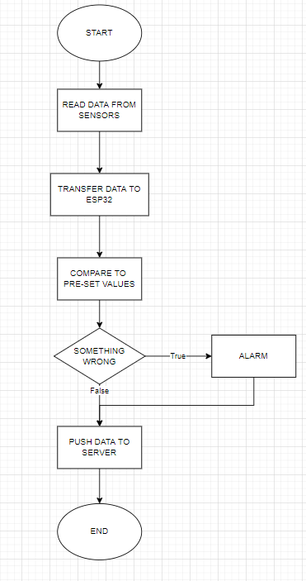

Figure 5. 34 Algorithm flowchart of monitoring systems

### **Fire alarm system works based on temperature sensor DHT11**

When the temperature at a certain location in the house rises suddenly (greater than 60oC), this system will automatically turn on the alarm speaker, when the temperature returns to below 60oC, the alarm system will stop working. This temperature value is taken from the output signal of the DHT11 temperature sensor.

The temperature signal from these 3 sensors will be input and processed in the arduino nano board, the received temperature signal will be compared with the fire alarm value threshold.

### **Gas leak alarm system**

The sensor's DOUT output signal is connected to pin 2 of the arduino nano circuit. When the gas concentration measured by MQ2 is above the allowable level, the sensor's DOUT pin will output a value of 0, this time the arduino board will output at digital pin 3 logic level 1 (corresponding to 5V). Activate the speaker to emit a warning chime.

### **Intrusion warning system**

When someone passes, the heat emitted by the body is consumed on the target as an infrared sensor, from this sensor will appear 2 signals at the output of the sensor and this signal will be amplified to high enough amplitude and put into the processing circuit to affect a control device or alarm.

# **CHAPTER 6: SMART HOME CONTROL AND MONITORING SYSTEM**

## **Learn about Wi-Fi and how it works.**

### **What is Wi-Fi?**

**In a nutshell, Wi-Fi, which connects to the Internet wirelessly, is the word stands for Wireless Fidelity, which uses radio waves to transmit signals. Wave Type, this radio is similar to telephone, television and radio waves. And on most of the today's electronic devices such as computers, laptops, phones, tablets ... all have can connect to Wi-Fi.**

Wi-Fi connection is based on IEEE 802.11 connection standards, and mainly Today Wi-Fi works on the 54 Mbps band and has the strongest signal within a distance of 100 feet (nearly 31 meters, you can just imagine that each floor of the house is 4 meters on average, then according to the theory of Wi-Fi waves broadcast on the second floor). 1 will still catch if you're on level 7 – that's in theory). In fact, in each house there are often many wave obstructions, so you only need to stand on the 4th or 5th floor to signal the signal already weak.

### **Working principles of Wi-Fi**

As we all know, it's also very simple, to get Wi-Fi waves, we need a set of Wi-Fi transmitters – are devices such as modems, routers. Input, Internet signal source (provided by ISP units such as FPT, Viettel, VNPT, CMC ... now). The modem device, the router will take the Internet signal through the wired connection converted into a radio signal, and sent to user devices such as smartphones, tablets, laptops ... This is the process of receiving wireless signals (also known as adapters) - the Wi-Fi card on the laptop, phone… and convert it into an Internet signal. And this process can be done completely in reverse, that is, the router, the modem receives the radio signals from the adapter and decodes them, sending them over the Internet.

### **Some common potting standards.**

Technically, Wi-Fi signals work sending and receiving data at frequencies 2.5GHz to 5GHz, much higher than the frequency of cell phones, radios…

Therefore, the Wi-Fi signal can contain a lot of data but is limited in range transmission – distance. And other types of waves, although low in frequency, can transmission over long distances???

Wi-Fi waves use the 802.11 connection standard in the IEEE (Institute of ) library

Electrical and Electronics Engineers), this standard includes four smaller standards: a/b/g/n. (You often see on modems, routers have these symbols)

The 802.11b standard is the weakest version, operating at 2.4GHz and can handle up to 11 megabits per second.

The 802.11g standard is slightly better than the b standard, although it also works in 2.4GHz frequency but it can handle 54 megabits per second.

The 802.11a standard transmits at a higher frequency of 5GHz and has a processing speed of 54 megabits/second.

Finally, the 802.11n standard, it operates on the 2.4GHz frequency but them processing speed is limited handle up to 300 megabits per second.

### **How does Wi-Fi work?**

Just like cell phones, Wi-Fi uses radio waves (radio waves) to transmit information over the network. Your computer includes a network card wireless will transmit the data sent into the radio signal.

Similarly, this signal will be transmitted through an antenna, a decoder code called router. After the decryption is complete, the data will be sent to the Internet via a wired Ethernet connection.

*How does Wi-Fi work?*

When the wireless network acts as a two-way street, the data received from the internet will also pass through the router and be encoded into a radio signal to the network card wirelessly on the receiving computer.

Most users know little or no idea how Wi-Fi works how.

Wi-Fi was originally developed as a way to replace Ethernet cables. Give up to now, Wi-Fi has become a popular technology that provides connectivity between devices.

“People can get used to using Wi-Fi as a way to connect to the Internet, because for most people it's the network they use at home or at homework,” said Edgar Figueroa, president and CEO of Wi-fi Alliance.

“However, Wi-Fi has evolved and now Wi-Fi can replace many types various cables such as video cable, audio cable, USB cable.” But the most important thing Wi-Fi is currently transporting more than 60% of the world's Internet traffic. Two radios allow web users to download data from the Internet as well as upload information – even the submit address via a communication browser counter 2

afternoon.

Wi-Fi is more complicated than terrestrial radio, that is, Wi-Fi uses a connection protocol Internet Protocol (Internet Protocol) to communicate. This language of the Internet creates the structure Wi-Fi architecture.

“Every transmission we send and receive requires authentication accept,” said Figueroa.

Imagine instead of sending data, you are transporting a data packet

worldwide and requires delivery confirmation. That's the mission assigned

Internet Protocol (Internet Protocol) must-do, only applies to each byte

transmitted.

And once the data is "flying through" the air in the radio waves, it is lost

interference, and become a "victim" from other Wi-Fi signals to radio waves

emitted from the microwave….

That's where the 2.4 GHz and 5 GHz Wi-Fi frequencies come in Wi-Fi can broadcast on both frequencies, to cut down your signal avoid interference and provide signal quickly from your wireless router to your computer.

“Basically, the same frequencies as two different FM radio stations”, Figueroa

speak. According to physics, lower frequencies can travel farther Wi-Fi, 2.4 GHz has a lower frequency, so it can "reach" to the machines far away than the 5 GHz Wi-Fi.

However, 5 GHz Wi-Fi can transmit more. “Imagine though you can go on a certain highway very far, but it's just a highway single-lane speed”, Mr. Figueroa describes about 2.4 GHz Wi-Fi.

5GHz Wi-Fi is also a highway but that road is not as far as you might think, but it has six lanes, so the vehicles can move faster on that path.

“The coverage of 5 Ghz Wifi can cover an entire house,” Mr Figueroa added. “Therefore, in most people's minds, the problem of way is not as important as speed.”

However, since the advent of cordless phones, many users have encountered

There must be a problem with the radio signal. The only way to fix this problem is to set up frequency to broadcast on a certain channel.

Most routers are "very good" at automatically detecting the best channels to use.

And 5GHz Wifi has more channels than 2.4GHz Wifi.

For users of unstable Wifi network, re-tweaking the network system will be much more useful and efficient than installing a network extender.

“Network extenders are growing in popularity,” says Figueroa.

However, the problem here is that the extender "pushes" a weak Wifi signal. Because, so if your wireless Internet can only transmit at 1/2 the old speed,

The extender will repeat that signal, outputting an even weaker signal

weaker than it.

Wifi also has some security features. To access the network, the user must

have a WPA2 password, aka WPA (the number 2 represents the second generation of WPA). This is where you enter the password to connect to the Wifi network.

There is also another security feature called Advanced Encryption Standard (also known as AES) was developed by the US government to ensure data is safe as it is transmitted from one device to another.

Perhaps the most important feature of Wifi is compatibility reverse. With this feature, all your old computers can connect to one the new router is "super fast".

## **IP Address**

IP is an address of a computer when participating in a network to help computers transfer information to each other accurately, avoiding loss. An IP address in a computer network can be thought of as your home address so that the postal worker can deliver the correct mail to you and not someone else.

Each IP address consists of two components:

* NET ID: used to identify systems in the same physical environment also known as Segments. Every system in the same segment must have the same Array Address. This address must be unique among existing networks.
* HOST ID: used to identify a workstation, a server, a Router or a TCP/IP station in the same Segment. The station address must also be unique within a network.

## **Blynk Application**

* Theoretical basis of APP Blynk

Blynk is a platform with iOS, Android applications that allows Arduino control,

Raspberry Pi, ESP8266. You can build control applications by dragging, drop the Widgets.

* **How it works**

Blynk is designed for IoT, it can remotely control hardware, display data

sensor data, data storage…Blynk consists of 3 parts:

**Blynk App:** allows creating interfaces from available Widgets

**Blynk Server:** transfer information between Smarthome and device. Blynk Server can be a cloud of Blynk or can be installed on a personal machine. Can be installed on Raspberry Pi.

**Blynk Libraries:** a library that provides a hardware connection to the server, handling orders come and go.

* **What does it take to get started with Blynk?**

**1. Equipment**

The device uses development kits such as Arduino, Raspberry, ESP32,...

**2. Smartphone**

The Blynk app can work on iOS and Android. Can be downloaded from above phone.

Blynk Library for Arduino: https://github.com/blynkkk/blynklibrary/releases/latest

In the Arduino IDE this library can be added from the Manager Libraries by searching the Blynk keyword and installing.

* **Blynk is actually a mobile app that allows users to create interface and control the device according to personal preferences. I choose Blynk for a number of reasons:**

**Easy to use:** So simple, just go to the store, install, then register for an account account and takes no more than 5 minutes to get used to.

**Beautiful and complete:** Blynk's interface is great, use it by dragging

drop, you need buttons, drag and drop buttons, you need graphs, drag and drop graphs, you need LCD, drag and drop LCD, in short, drag and drop whatever you need.

**Not programming android or ios:** If you don't have the knowledge to do

app on your phone, controlling the device from your own smartphone is very effective is extremely difficult and complex. Thanks to blynk we can skip it programming step to create app. Can quickly try and apply your project myself into reality.

**Rapid testing can be monitored anywhere have internet.**

## **Software**

* **Introduction to programming software**

Arduino IDE [15] is an open-source integrated development environment that allows users to write code easily and upload it to the board. Development environment written in Java based on other open-source programming language and software. This software can be used with any Arduino board.

The Arduino IDE is a cross-platform integrated development environment that works with an Arduino controller to write, compile and upload code to the board. This software provides support for a wide range of Arduino boards such as Arduino Uno, Nano, Mega, Pro or Pro Mini, .... General language for Arduino C and C++, so the software is suitable for programmers who are familiar with both languages. Features like syntax highlighting, automatic indentation, ... make it a modern alternative to other IDEs. Arduino IDE has a very rich sample code library, writing programs on the Arduino IDE is quite easy plus Opensource written specifically for Arduino is increasing.

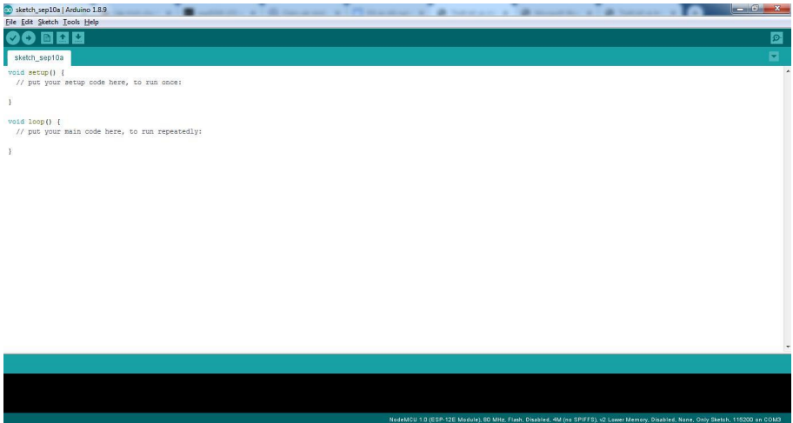

Figure 6. Interface of the Arduino software

This is a tool to help write and load code for Arduino boards as well as NodeMCU circuits. Visit the Arduino home page http://arduino.cc to download the software and install it. The software is supported for free for users, with the latest update being Arduino 1.8.

After downloading, additional libraries are required to be used with the module NodeMCU ESP32. Go to File → Preferences, go to the Additional Board textbox Manage URL add the following link:

Then click OK to accept.

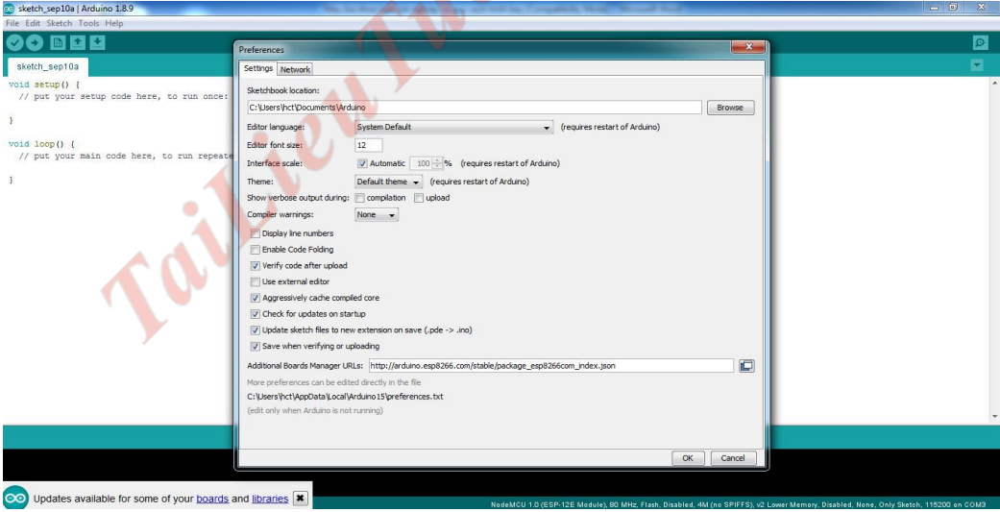

Figure 6. Arduino Setup Preferences

Next go to Tool→Board→Boards Manager

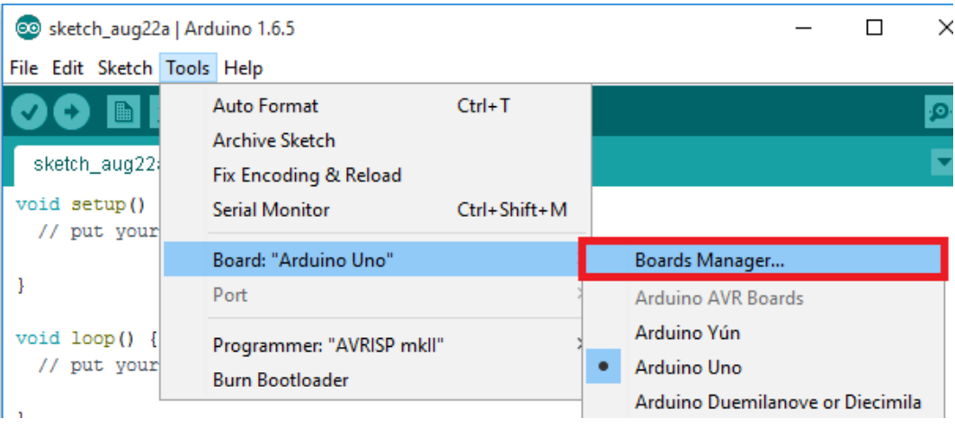

Figure 6. Arduino boards manager

Wait a moment for the program to search. We scroll down and click on ESP32 by ESP32 Community, click Install. Wait for the software to automatically download and Setting.

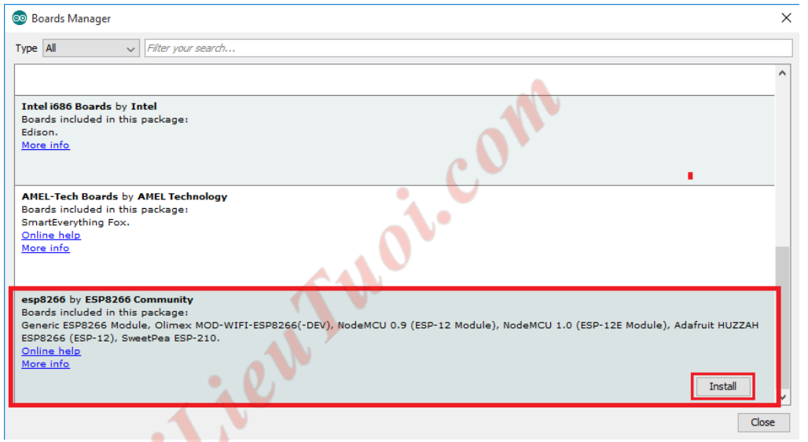

Figure 6. Arduino setup ESP32 librabry

Connect the USB-to-UART module to the computer.

Go to Tool→Board→Generic ESP32 Module, select the COM port corresponding to corresponding USB-to-UART module. Similarly, we import the library for the measuring sensor DHT11 temperature.

* **Create a Blynk project**
* Step 1: Download App Blynk

Android: <https://play.google.com/store/apps/details?id=cc.blynk&hl=en_US>

IOS: <https://apps.apple.com/us/app/blynk-iot-for-arduino-esp32/id808760481>

* Step 2: Click “New Project” in the app to create a new Blynk app. Give the application any name.

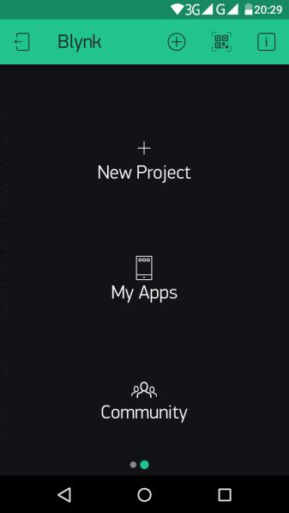

Figure 6. Create Blynk project

* Step 3: Blynk works with hundreds of hardware and connection types, so you'll need to choose your hardware and connection type. In this project, I have selected the hardware type as NodeMCU and the connection type as WiFi as shown below. Finally, you click the “Create” button to create a new application.

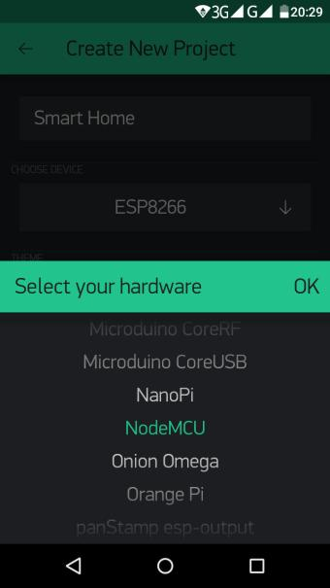

Figure 6. Create Blynk project

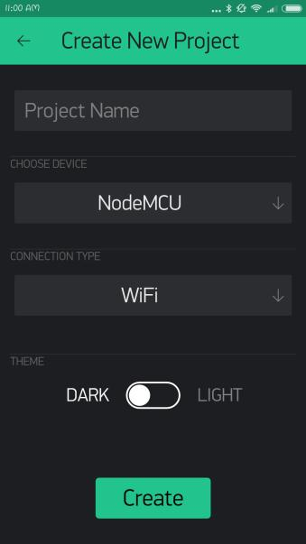

Figure 6. Blynk hardware configuration 2

You will now receive an email with an authentication code (Auth Token). You will need to insert this code into the Arduino code.

* Step 4: Add widgets to the project
* Click the '+' icon in the top right corner. Now the Widget box will open, we need 4 buttons to control the relay. You add 4 buttons by selecting it here.

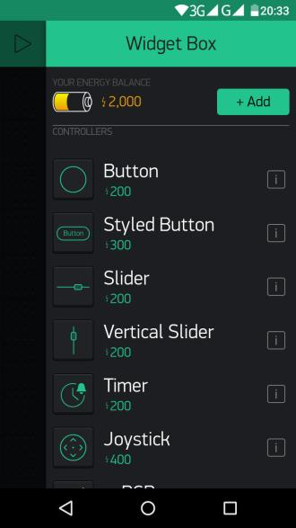

Figure 6. Blynk widget configuration

* Now click Button from home page to configure. Name the Button (Example: Light). Select Output Pin D0 and select Mode as Switch. Then go back. Likewise, configure the rest of the buttons.

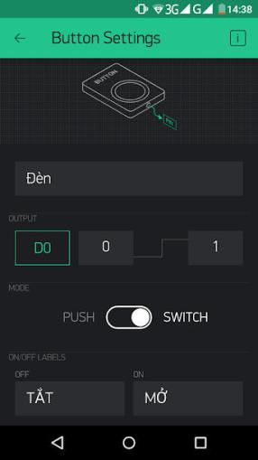

Figure 6. Blynk switch configuration

* You have created the user interface (GUI) for the application as shown below. Through this interface you can control electrical appliances in your home.

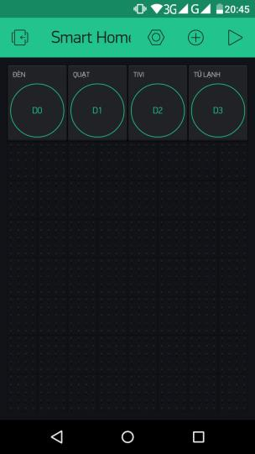

Figure 6. Blynk interface 1

* Step 5: Upload Firmware
* Now connect the NodeMCU to your computer and open the Arduino IDE software.

Install the Blynk library from here <https://github.com/blynkkk/blynk-library> if you're doing it for the first time. You need to download the zip file, extract it and place it in the libraries folder.

* Copy the program below or open the Arduino software. Choose File → Examples and navigate to Blynk → WiFi → NodeMCU.

You only need to modify three things in this code.

Paste the authentication code (Auth Token) you received in your email into ‘YourAuthToken’. Then, add your wifi name and password in the code at the locations 'YourNetworkName' and 'YourPassword'

/*************************************************************

Download latest Blynk library here:

https://github.com/blynkkk/blynk-library/releases/latest

Downloads, docs, tutorials: http://www.blynk.cc

Sketch generator: http://examples.blynk.cc

Blynk community: http://community.blynk.cc

*************************************************************

This example runs directly on NodeMCU.

Note: This requires ESP8266 support package:

https://github.com/esp8266/Arduino

Change WiFi ssid, pass, and Blynk auth token to run 🙂

*************************************************************/

#define BLYNK_PRINT Serial

#include <ESP8266WiFi.h>

#include <BlynkSimpleEsp8266.h>

// You should get Auth Token in the Blynk App.

// Go to the Project Settings (nut icon).

char auth[] = “YourAuthToken”;

// Your WiFi credentials.

// Set password to “” for open networks.

char ssid[] = “YourNetworkName”;

char pass[] = “YourPassword”;

void setup()

{

// Debug console

Serial.begin(9600);

Blynk.begin(auth, ssid, pass);

Blynk.syncAll(); //This will sync the last state of your device

}

void loop()

{

Blynk.run();

}

Once done, select the correct Port and Board then load the program. That's it, done! Your smart home project is ready. You can check activity through your Blynk app by turning ON and OFF. That way you can control the devices in your home from anywhere in the world with an internet connection.

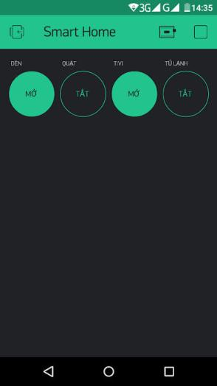

Figure 6. Blynk interface 2

* **Create Blynk from PC:**

First, go to https://blynk.cloud/ to login, if you do not have an account, select **Create new account** to register. Enter your email name, then tick **Sign Up**.

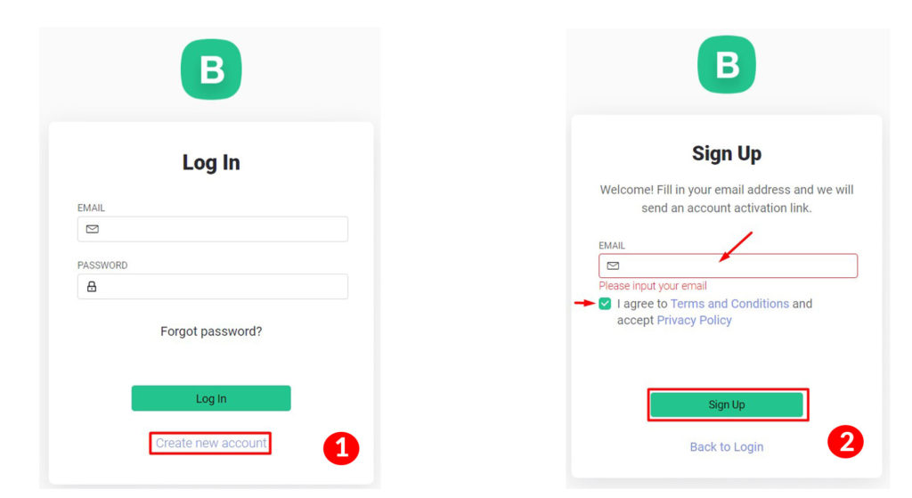

Figure 6. Blynk PC login

They will send you an email, then select **Create Password** to create a password. After you have an account, log in to select **New Template**, enter your name and select the full name as shown below:

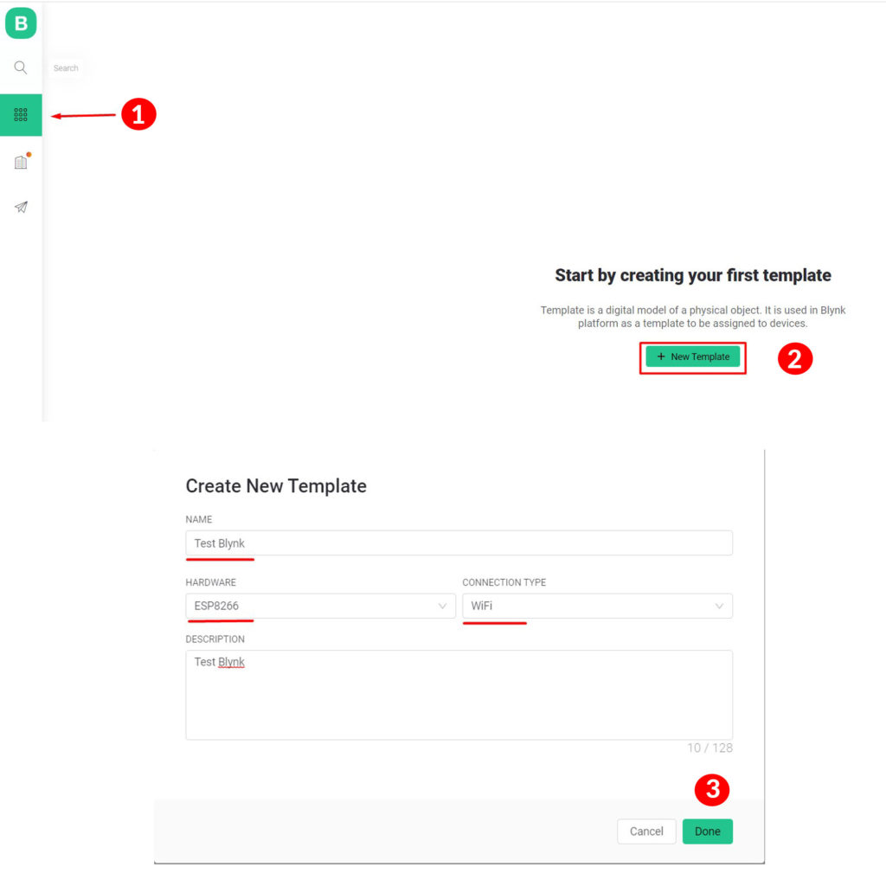

Figure 6. Blynk PC template creation

After creating, the interface below will appear, we copy the Template code to paste it into the code, the link to download the code will be in the section below.

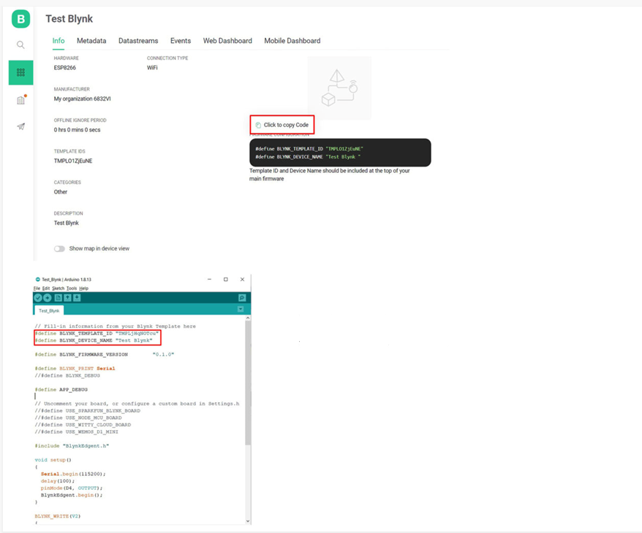

Figure 6. Blynk PC setup application

Next, select **Datastreams** -> **Virtual Pin** -> enter the full datastream of Pin -> **Create**

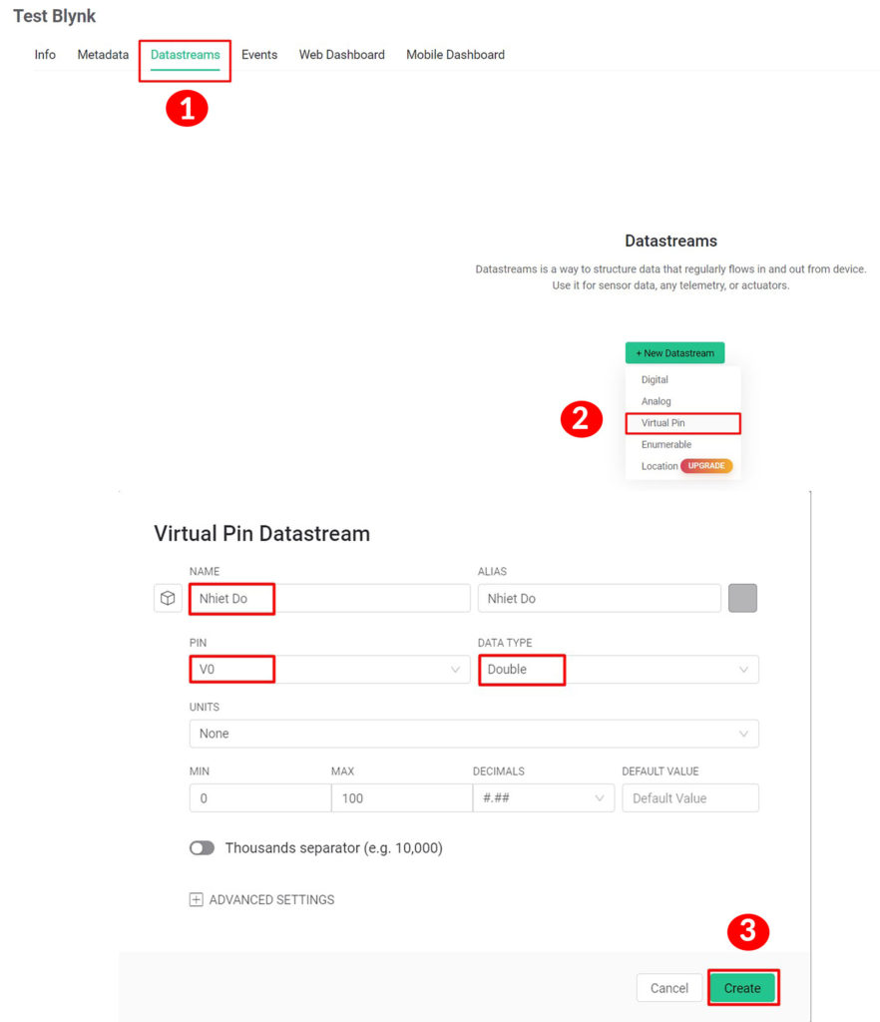

Figure 6. Datastreams Blynk PC configuration Virtual pin 1

In this example, I send the temperature and humidity sensor data to Blynk, so you create the same Pin V1 as the humidity, and create V3 as the Led control pin:

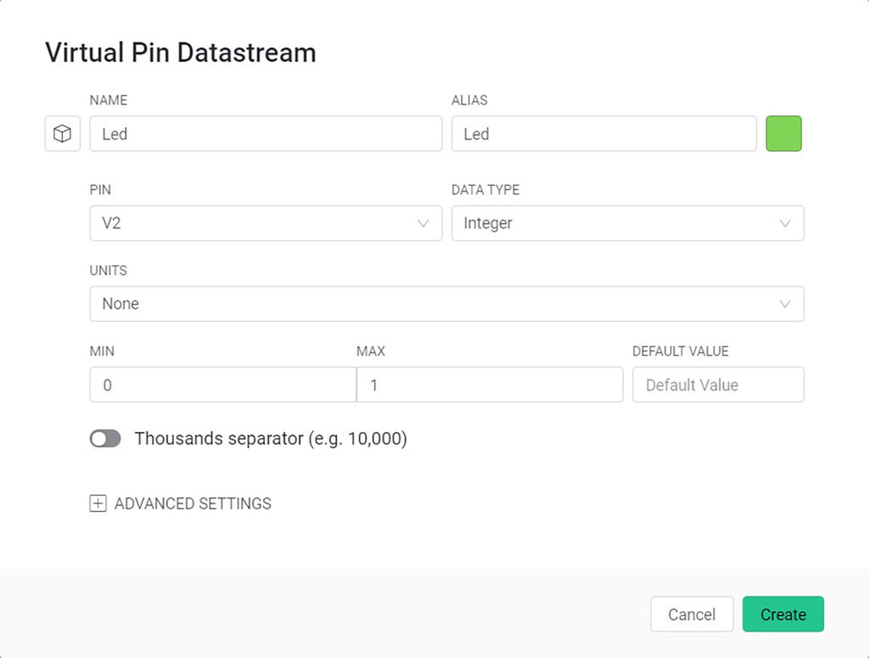

Figure 6. Datastreams Blynk PC configuration Virtual pin 2

After creating the battery, we choose **Web Dashboard**, drag the **Gauges** on the left to display temperature and humidity, **Switch** to turn on and off Led, a chart to display the temperature (the free version only displays the temperature) display 1 chart), press the settings icon to select each appropriate display Pin.

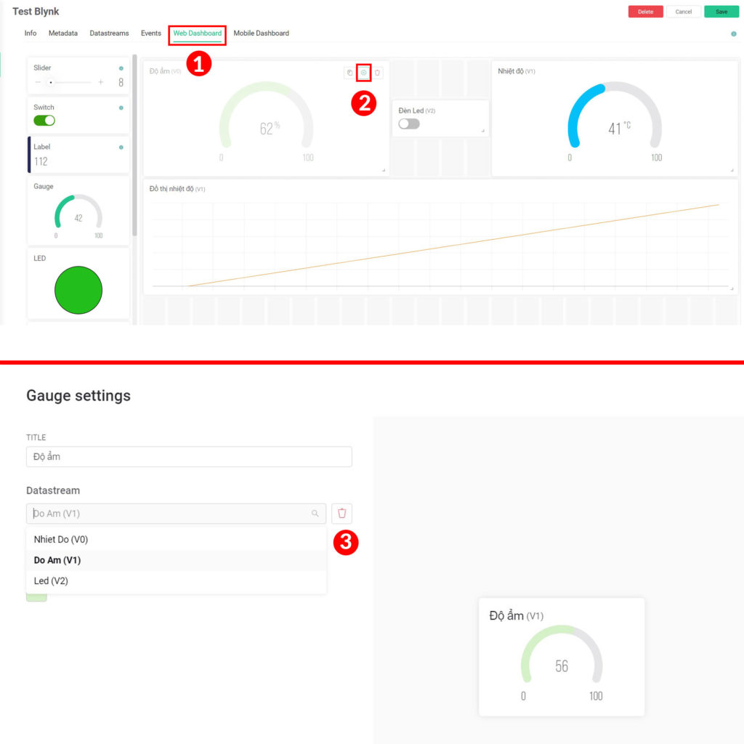

Figure 6. Blynk PC dashboard 1

After selecting, click **Save** to save the settings:

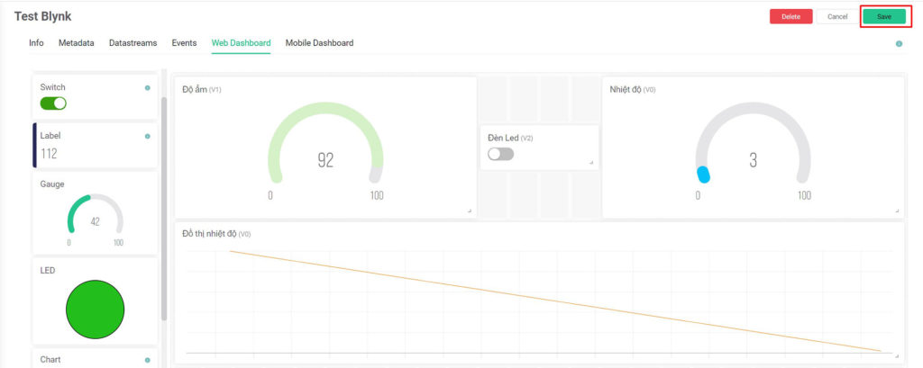

Figure 6. Blynk PC dashboard 2

Next, select the **Search** icon -> **New Device** to select the device from the **From template**:

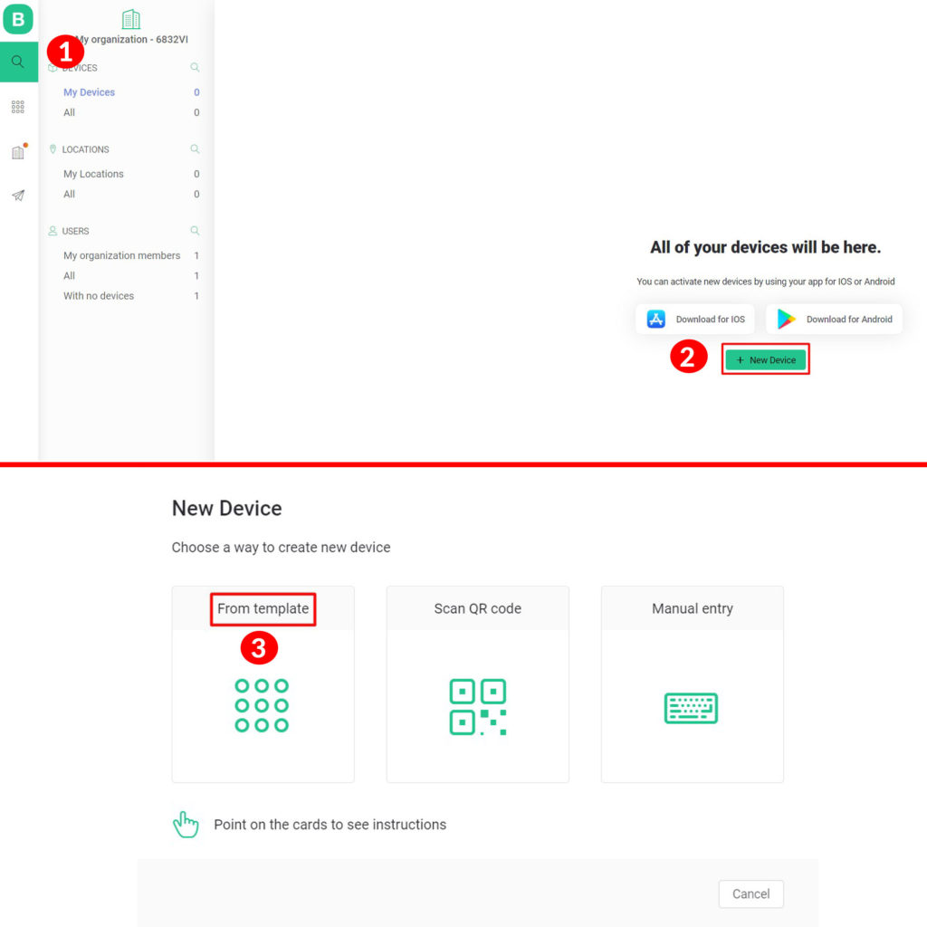

Figure 6. Blynk PC new device

Select the name of the template you created -> **Create**, then see the result:

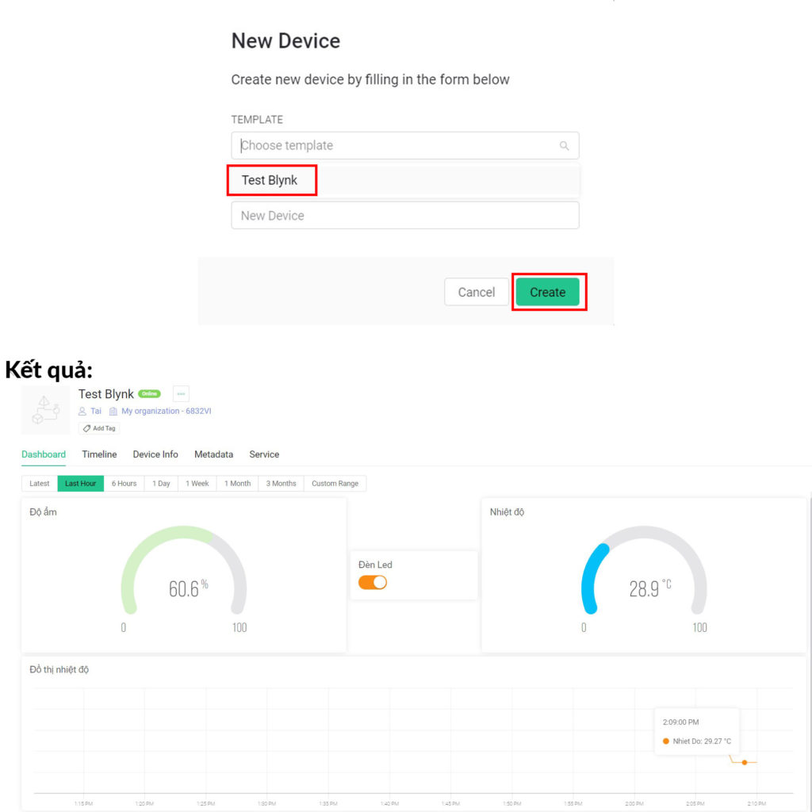

Figure 6. Blynk PC new device result 1

**Result:**



Figure 6. Blynk PC new device result 1

## **Design of monitoring and control system via internet**

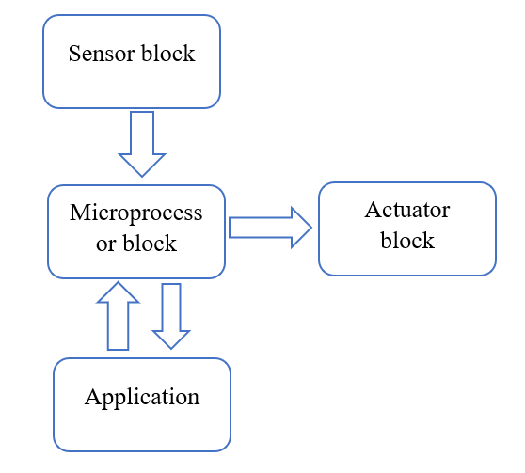

Figure 6. Block diagram of the monitoring and control system

1. *Components of the monitoring and control system:*

* Security monitoring, temperature, humidity, humidity monitoring, fire alarm, gas leak monitoring.
* Controls and displays the status of doors, indoor temperature and humidity, gas levels, etc., along with several other actuators.

1. *Monitoring system requirements:*

* Display security status on/off, display indoor temperature and humidity values.
* Control home appliances through the internet.

The monitoring and control system consists of 3 main components:

* Sensor block: collects data from sensors and then sends it to the microprocessor block.
* The microprocessor block is responsible for processing data before uploading to the phone application or receiving control signals from the phone application to control lighting and air conditioning equipment.
* Phone application: has the role of reading information sent from the microprocessor block and then displaying it on the phone interface and sending control commands from the user back to the processor block.
* Execution block: includes lights, air conditioners, warning peripherals. This block receives instructions directly from the processor block and then takes the appropriate action.

In this study, the system of sensors is used to collect data from the external environment, then perform processing, send commands to the actuator and send it to the phone application. The mobile app is built through the existing Blynk app platform.

The ESP32 MCU node has developed a set of Wi-Fi libraries that allow users to directly write code to connect to the Blynk app application right in the Arduino editor.

## **Principle of data transmission control:**

* Smart home control system controlled via Blynk application is controlled via 2 Arduino Nano chips and Node MCU32 via Wi-Fi. In which both chips are responsible for collecting signals from sensors, processing and controlling smart home devices, but the chip is responsible for connecting Wi-Fi with Blynk app to control the smart home system is Node MCU ESP32
* For each project, the Blynk application will send you an Auth Token to enter in the code of the Node MCU ESP32 microcontroller board, the next thing you need to do is set up the Node MCU ESP32 code to connect to the Wi-Fi address that your Blynk application is connected. The transfer of data and control from the application to the processor is handled mostly through the built-in library of Blynk.

## **Principle analysis in controlling a specific mechanism:**

* **Hardware:**
* Modem, cable
* Node MCU ESP32 (main)
* Arduino Nano (Sleeping room)
* Led’s sleeping room
* Analyze the control principle and transmit status data of the bedroom lights through the code below:
* Code from the Node MCU ESP32 controller:

Mission:

+ When manipulating the buttons on the console, the control signal is transmitted to the corresponding controller that manages the joystick device.

+ Get device status signal when we use hard button.

# **CHAPTER 7: DESIGN AND PRODUCTION OF EXPERIMENTAL MODELS**

## **Results achieved**

The actual house model has a size of 1000x800 mm, divided into 7 parts corresponding to 1 living room, 1 bedroom, 1 movie room, 1 kitchen, 1 garage, WC area and front garden. Combined with a control circuit block consisting of 1 Arduino Nano, 1 Node MCU ESP32.

Use servo motor to describe the process of controlling the opening and closing of the door. This motor has a rotation angle of 180o and is capable of adjusting the rotation angle according to the width of the pulse time to reach a value of 1.

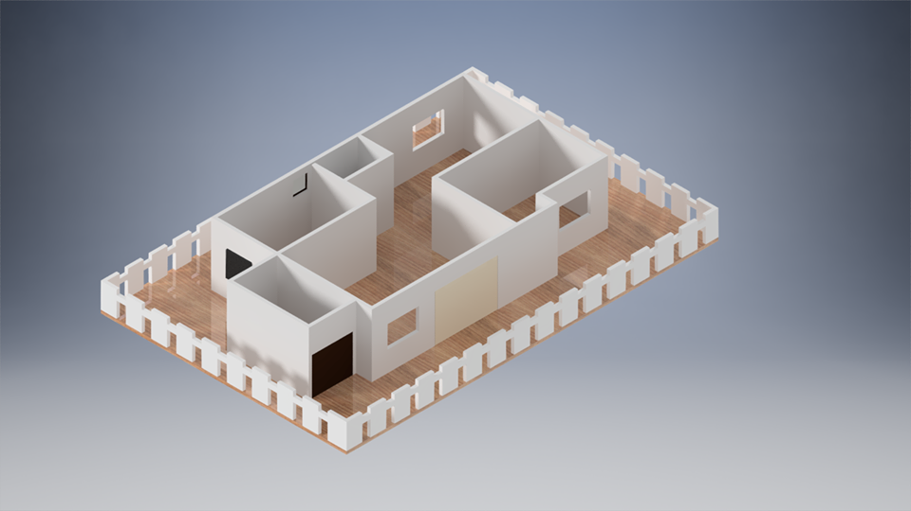

Figure 7. 3D Smart home model

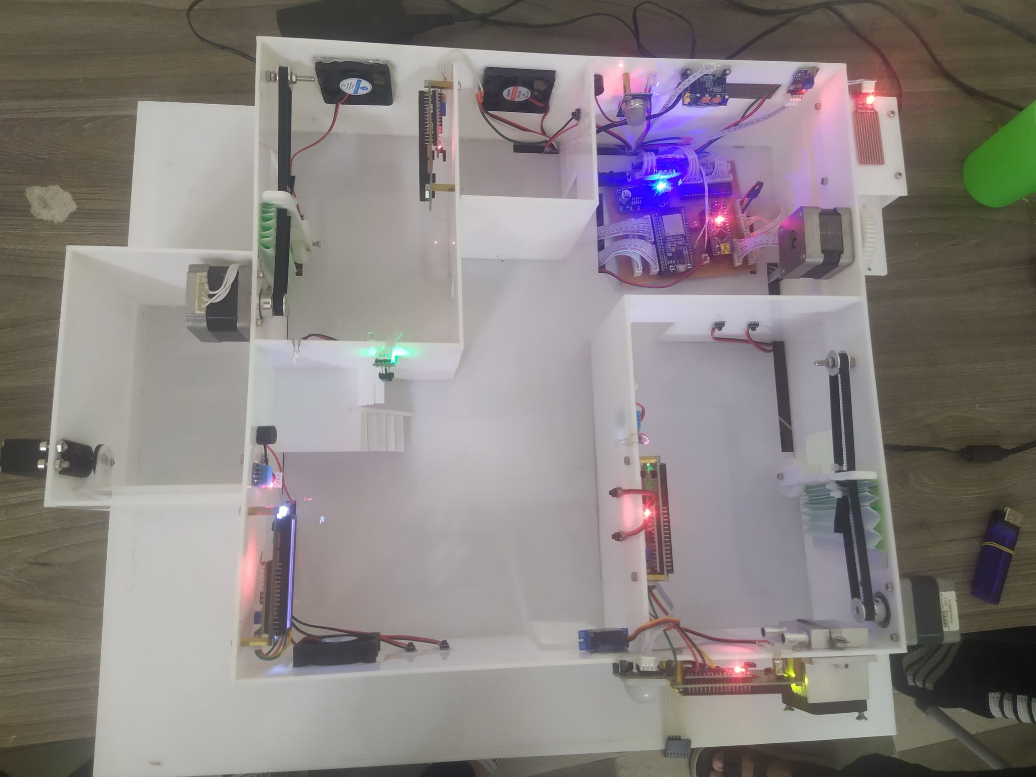

Figure 7. Realistic smart home model 1

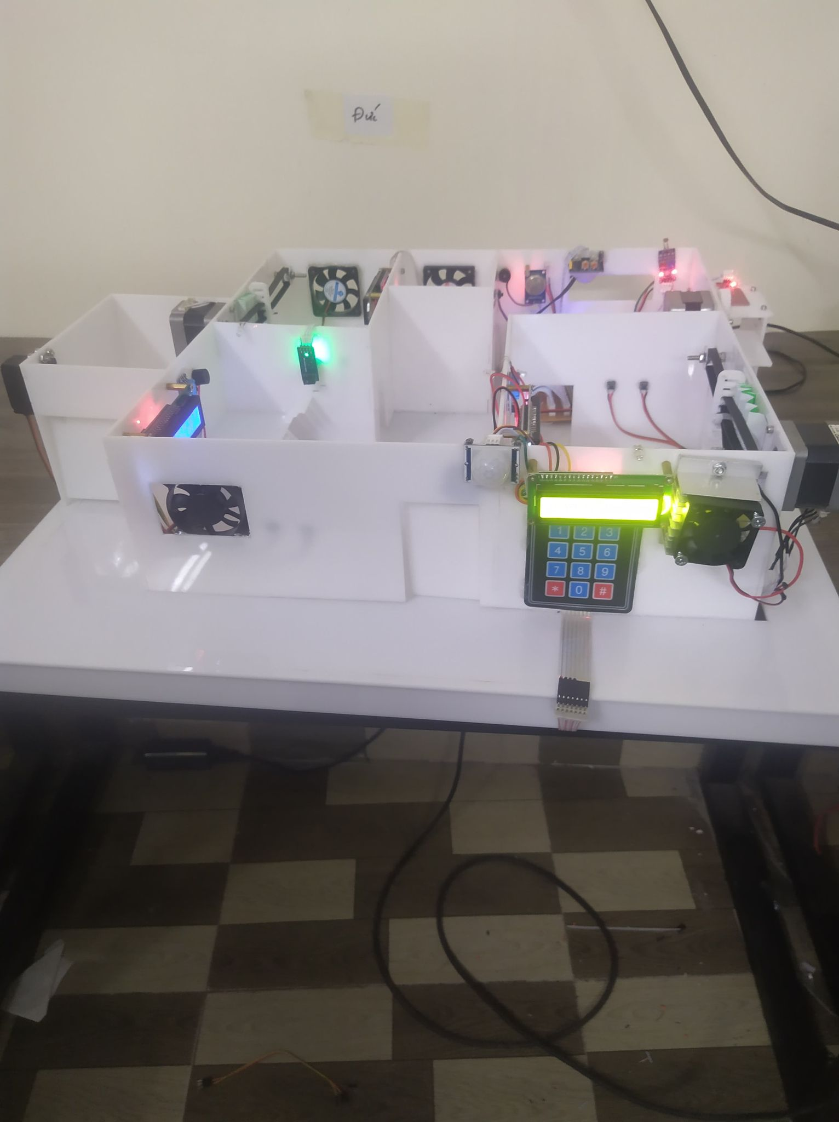

Figure 7. Realistic smart home model 2

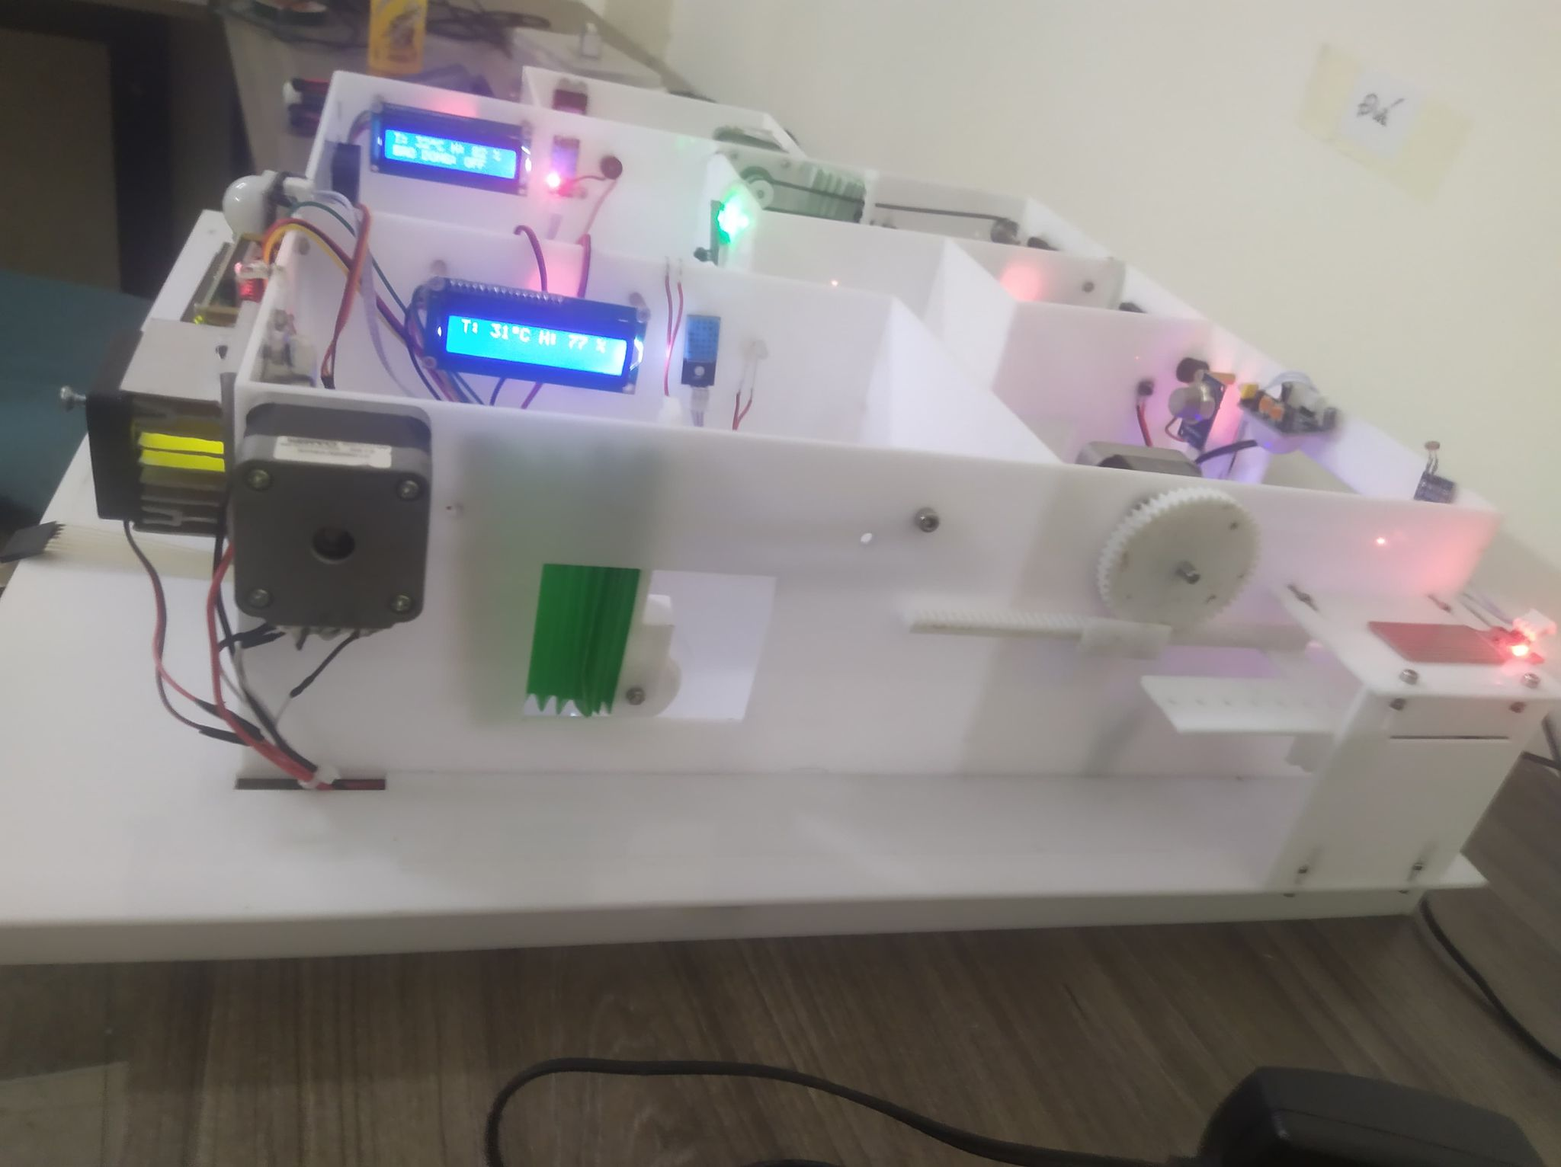

Figure 7. Realistic smart home model 3

Through running the experiment, there are some results:

* Using a smartphone with an internet connection to access the monitoring and control application, and to be able to control the device.
* The system runs relatively stable, meeting the initial requirements.

## **Monitoring and control interface**

The interface of the app is easy to use:

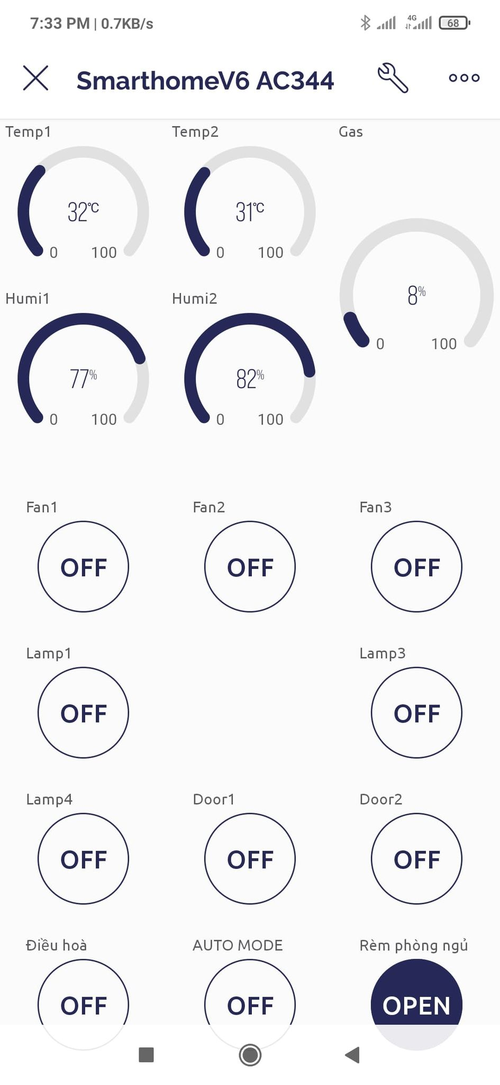

Figure 7. User interface of Blynk application

Structured console:

* Control and report the opening and closing status of doors.
* Monitor and control living room, playroom, and bedroom.
* Gas leak monitoring, house intrusion monitoring.
* Data will be sent to the app continuously.

## **Comment**

* There are some parts of the system that we were concerned about:
* The value of sensors is not 100% accuracy
* The clothesline and curtains automation system has been stuck sometimes while activating because we haven’t found a correct way to handle the ratio between the distance of the curtain and clothesline with the rotation of the motor
* The mechanical system is not yet rigid
* The cooling system is not good enough so the Peltier cooling module can’t be activated more than 15p – 20p
* The control signal processing from the Blynk application to our system has been delayed sometimes
* Some parts of the system have been controlled by the application yet

# **CHAPTER 8: CONCLUSION**

## **1. Conclusion**

Since this is a fairly new topic, in the process of researching we have encountered certain difficulties. But with the passion and enthusiastic guidance of the teachers plus the effort to explore, the passion to discover new things has helped us achieve the following results:

* Overview of monitoring and control systems over the internet, and smart homes. At the same time, we also know the usage situation and development trends of Vietnam and other countries in the world.
* Successfully designed a smart home model.
* Learn the basis and meaning of controlling devices over the internet.
* Understand the working principle of the modules in the system and how to connect them.
* Run the experiment and evaluate the results.

Besides the obtained results, the model still has many technical limitations such as the ability to expand the number of monitoring and control variables, the occurrence of noise, the application interface response time is sometimes long.

**2. Future work**

The control and monitoring system via the internet has great significance in many aspects of life such as: security, national defense, livestock, health care, family, farming, etc. The mastery of this problem. there are still certain limitations, especially for a country that is developing science and technology like us. Through this topic, I want to use the knowledge learned during the student period to make access to technology and trends of the world.

Through this project, I would like to suggest some development directions for the system:

* Install surveillance camera system for the system.
* Improve the accuracy of the value of sensors
* Improve the accuracy of the actuators block
* Improve the gara system by allowing more than 1 vehicles stored in
* Improve the security of our living room by interacting magnetic card system or fingerprint system
* Improve door system working like the elevator door mechanism
* Improve the cooling system
* Improve the anti-theft system by image recognition
* Improve the mechanical system
* Application of monitoring and control systems in healthcare and education.
* Control smart devices through voice
* Build a management software on mobile devices, and a management software on the web, which has the ability to automatically notify users of adverse conditions.

# **References**

1. [Arduino.vn](http://arduino.vn/)
2. <https://startingelectronics.org/>
3. <http://vi.Wikipedia.org/>
4. Htt://google.com.vn/
5. <https://dientuviet.com/nha-thong-minh-su-dung-blynk-va-nodemcu/>
6. <https://nshopvn.com/blog/huong-dan-cai-dat-va-su-dung-blynk-new-2-0-tren-arduino-ide-voi-esp8266/>
7. <https://microcontrollerslab.com/74hc595-shift-register-interfacing-arduino/>
8. <https://dientutuonglai.com/tim-hieu-74hc595.html>
9. <https://nshopvn.com/product/nguon-adapter-12v-5a-2/>
10. <https://dientu360.com/nguon-adapter-24v-5a-loai-tot>
11. <https://arduinogetstarted.com/tutorials/arduino-button>
12. <https://arduinogetstarted.com/tutorials/arduino-keypad>
13. <https://www.adafruit.com/product/419>
14. <https://deviot.vn/blog/giao-tiep-i2c.05019305>
15. <https://dientutuonglai.com/chuan-giao-tiep-i2c-la-gi.html>
16. <https://www.watelectronics.com/lcd-16x2/>
17. <https://arduinokit.vn/giao-tiep-i2c-lcd-arduino/>
18. <https://banlinhkien.com/quat-tan-nhiet-5v-3x3x1cm-30105v-p6652368.html>
19. <https://nshopvn.com/product/module-2-relay-voi-opto-cach-ly-kich-h-l-12vdc/>
20. <https://www.electronicshub.org/what-is-relay-and-how-it-works/>
21. <https://banlinhkiendientu.vn/so-nong-lanh-la-gi/>
22. <https://nshopvn.com/product/cam-bien-mua/>
23. <https://medium.com/@kekreaditya/ir-infrared-obstacle-avoidance-sensor-with-arduino-714837ad9ef5>
24. <https://chotroihn.vn/module-cam-bien-anh-sang-tai-linh-kien-dien-tu-3m>
25. <https://nshopvn.com/product/cam-bien-vat-can-hong-ngoai/>
26. <https://batiea.com/bai-viet/cam-bien-hong-ngoai-la-gi-nguyen-ly-ung-dung-va-nhung-dieu-can-luu-y>
27. <https://hancatemc.com/dong-co-buoc-la-gi-cau-tao-cua-dong-co-step.html>
28. <https://nshopvn.com/product/cam-bien-than-nhiet-chuyen-dong-pir-hc-sr501/?gclid=CjwKCAjwrZOXBhACEiwA0EoRD7gXyQZK_3BGibikzzps7_4SZAr4Uv8ACAHehiGnWADJn4Hj0h2nHxoCWdgQAvD_BwE>
29. <https://blog.mecsu.vn/dong-co-servo-mg996r/>
30. <https://hshop.vn/products/dong-co-rc-servo-mg996-2>
31. <https://icdayroi.com/driver-a4988-stepper-motor>
32. <https://lastminuteengineers.com/a4988-stepper-motor-driver-arduino-tutorial/>
33. <https://deviot.vn/tutorials/esp32.66047996/tong-quan-ve-esp32.18482631>
34. https://esp32.vn/